Leeds Beckett University

Cloud Implementation and Analysis

Module: Cloud Computing Development (CCD)

Student Name: Ayush Thapa

Student ID: 77297990

Year: 2023

Abstract

This academic report delves into the landscape of cloud computing, focusing on the comprehensive exploration of cloud service providers and models.

Furthermore, the report examines various cloud models, like Infrastructure as Service (IaaS), Platform as a service (PaaS), Software as a Service (SaaS). The vendors who provide this service are also examined. Through this examination, a critical assignment is made to determine the provider and cloud model for the deployment of a web service.

The report concludes with the practical application of this analysis, selecting AWS Elastic Beanstalk as the preferred PaaS offering from Amazon Web Service (AWS) for deploying a web application.

Contents

Introduction 4

Literature Review 7

Cloud vs on premise 7

Cloud Services and their types 9

Cloud vendors 16

Critical Review 22

Specification 27

Development and Deployment 28

Development 28

Deployment 39

Conclusion and Reflection 56

References 58

# Introduction

The term Cloud, refers to server that are utilized over the internet, and server contains the software and databases. Cloud Computing allows users and companies to be free from responsibility managing physical servers, or even develop the applications on their local machine. To support this, data centers for cloud servers are distributed worldwide (Cloudflare,2023).

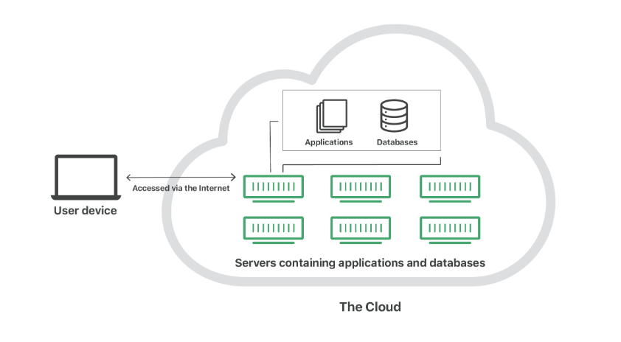

The cloud allows the user to connect to a worldwide network, providing access to a changeable set of computing resources like networks, servers, storage, applications, and services. These resources can be utilized by quickly deploying and deactivating with minimal need for management or any sort of interaction with the service provider (Mell & Grance, 2011). The cloud computing is defined by its five essential characteristics, three service models and four deployment models (Mell & Grance, 2011).

On demand service:

User can independently and instantly access and manage computing resources without needing direct interaction with the service provider. This feature provides a quick and automated way for the user to get the computer service they require (Bhatia,2023).

Broad network access:

User can access cloud services over the network and with wide range of devices like smart phones, laptop and desktop computers. Cloud service is easily accessible from different locations and through different means, providing flexibility and convenience for user to connect to the cloud. The quality of the service is dependent on the latency and bandwidth of the network (Bhatia,2023).

Resource pooling:

The computer resources like processing power, memory, storage and bandwidth, are aggregated into a common pool that can be used by multiple users or application as needed. It allows for more efficient utilization, as the resources are dynamically allocated and reassigned based on demand. It enables a flexible and cost-effective approach to managing computing resources, ensuring that they are used efficiently across multiple tasks or users rather than dedicated to a single purpose (Bhatia,2023).

Rapid elasticity:

Users can rapidly and easily expand or shrink their usage of resources like processing power, storage, or bandwidth. It provides service which can accommodate a sudden increase in demand during busy period and scale down during quitter time which ensures that necessary resources are available when needed and aren’t paying for unused resources (Bhatia,2023).

Measured Service:

The usage of computing resources can be tracked and metered. Cloud provides services to monitor, measure and record how much services user consumes. This allows for the transparent and accountable usage of resources (Bhatia,2023)

These essential characteristics collectively define the fundamental attributes of cloud computing, enabling a scalable, flexible, and efficient approach to services. The subsequent section of the report explores service models and the deployment models.

# Literature Review

## Cloud vs on premise

Cloud computing involves delivering computing services via the internet rather than relying on local servers or personal computers. On the other hand, on-premises refers to the traditional approach of hosting and managing computing resources within an organization's own physical data center (Team Cleo, 2023).

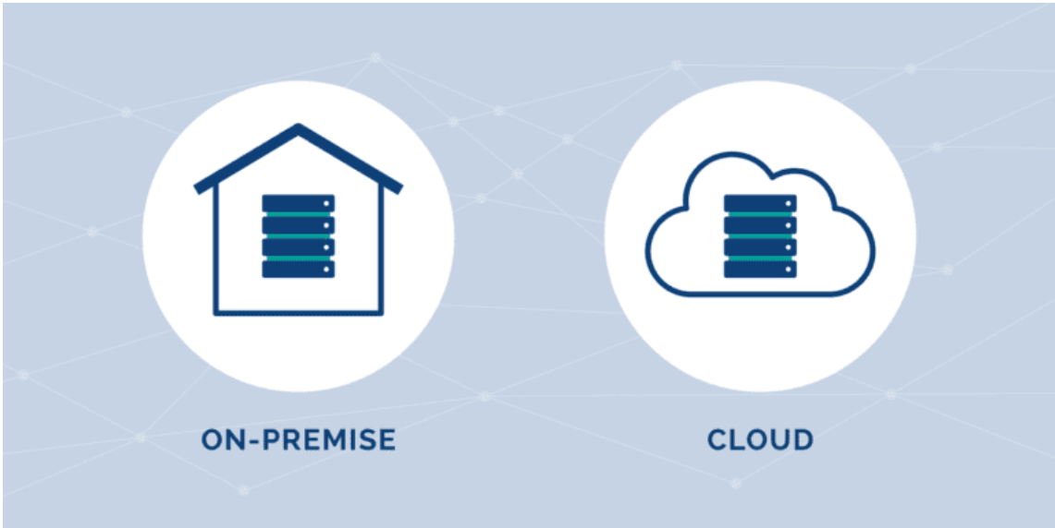

Differences:

Deployment:

On-Premises: The application or resources are deployed within the server of the company, the company need to buy a server and the organization needs to maintain the application. (Team Cleo, 2023).

Cloud: Resources are hosted by a cloud provider, and the company can simply access and use them as needed without every needing to manage the infrastructure under the hood. (Team Cleo, 2023).

Cost:

On-Premises: As Organizations are the one who have the server so if they want to expand it or have regular maintenance, they need to bear the costs of that server, the cost is also generated by the hardware, power consumption, and space (Team Cleo, 2023).

Cloud: Costs in the cloud computing model are based on usage, and organizations only pay for the resources consumed, without additional maintenance and upkeep expenses. Prices can adjust based on usage (Team Cleo, 2023).

Control:

On-Premises: Enterprises retain full control over their data, making it ideal for companies in highly regulated industries with privacy concerns (Team Cleo, 2023).

Cloud: The ownership of data in the cloud is a challenge, as data and the encryption keys for the server are with the cloud provider. In case of downtime, accessing data may become challenging. This aspect can be a concern for some companies and vendors (Team Cleo, 2023).

These are the differences between cloud and on premise.

## Cloud Services and their types

In cloud computing there are divided into three main models i.e. IaaS, PaaS, SaaS. These models are divided according to the different level of control, responsibility, management, use-case, security, flexibility and scalability they provide (Kumar, 2023).

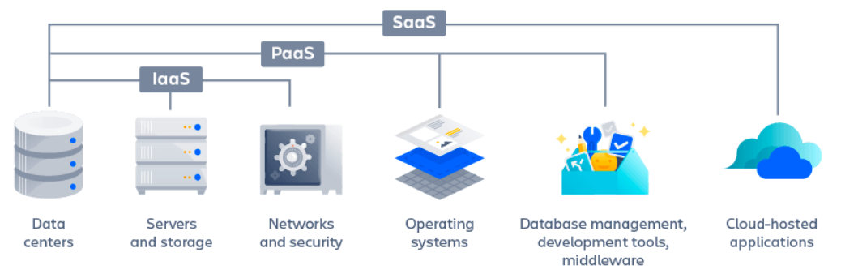

Infrastructure as a Service (IaaS):

In this type of model, the cloud provider rents the raw hardware resources such as storage, server and networking resources. User can get this resource on internet using pay-as-per use model. This model eliminates the need for every organization to maintain the IT infrastructure. Here, the cloud service provide maintains and manages the hardware so user can only focus on installing, configuring and managing software (GoogleCloud, 2023).

Types of IaaS:

Private Cloud:

It covers the infrastructure located on the customer’s premises. Examples: On-premise Data Centers, Dedicated Private Cloud Provides (The IoT Academy, 2023).

Public Cloud:

The cloud situated in data center of the company that provides the cloud computing platform. Examples of such clouds are: Microsoft Azure, Google Cloud Platform, Amazon Web Service (AWS) (The IoT Academy, 2023).

Hybrid Cloud:

Combines two by allowing user to choose the best feature of each. Example: VMware Cloud on AWS, Azure Hybrid Cloud, Google Anthos (The IoT Academy, 2023).

Benefits:

Economical:

The enterprise will pay for the model they are using and they need to pay based on the resource used and additional they only need to pay for the resource like networking, compute and storage (GoogleCloud, 2023).

Reliable:

Cloud providers have many data centers over the world and they have backup for every machine so even if any component of the hardware resource fails, the service will not be affected (GoogleCloud, 2023).

More innovation:

The deployment becomes easy in cloud, due to which the team don’t need to spend weeks and months configuring servers to run application, they can easily deploy the application using cloud and instead can spend that time on the application to make it better (GoogleCloud, 2023).

These are the benefits of Infrastructure as a Service (IaaS).

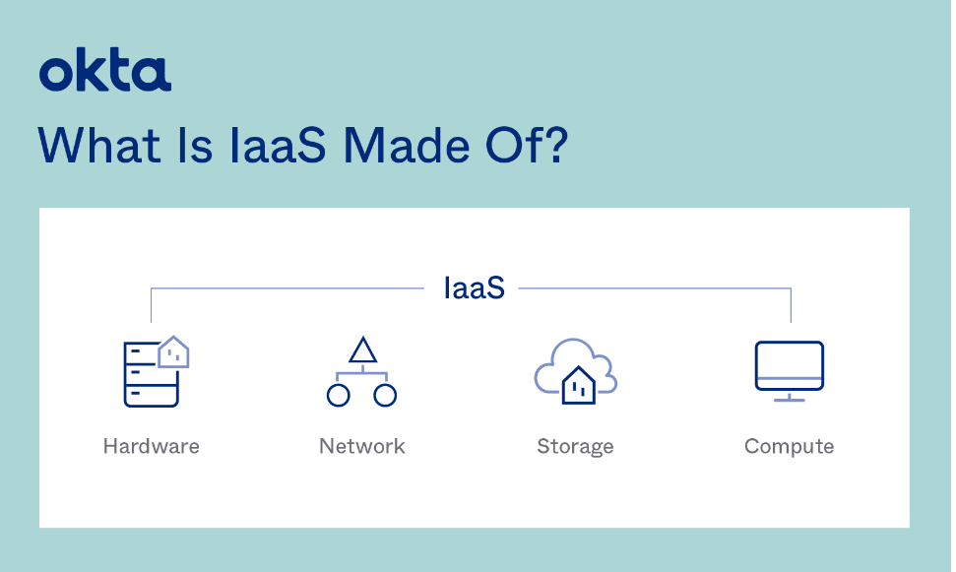

Platform as a Service (PaaS)

In PaaS, the raw hardware resource is provided with addition of software resources. Now, user don’t need to install any run time environment for the application. This will help the user to develop, run and manage business application without maintain the infrastructure (Kanade, 2022). In this model, the user will not interact with the operating infrastructure, they are managed by the Cloud Service Provider.

Types of PaaS:

Some of the types of PaaS are: Public PaaS, Private PaaS, Hybrid PaaS, Communication PaaS, Mobile PaaS, Mobile PaaS, Open PaaS, iPaaS, MWaaS are types of PaaS (Trad, 2023).

Benefits:

Cost effective:

As the hardware is provided the user doesn’t need to invest in those hardware and similarly the OS and other software are also already there as a package, Developers can simply focus on working on the code without needing to worry about servers, development tools etc. (Smact Works, 2019).

Maintenance:

The service provided by cloud provider has automated security patches and updates which ensures that application operates on the recent version and there are no security vulnerabilities. It removes the need of specialist team to maintain environment daily(Smact Works, 2019).

These are the benefits of Platform as a Service (PaaS).

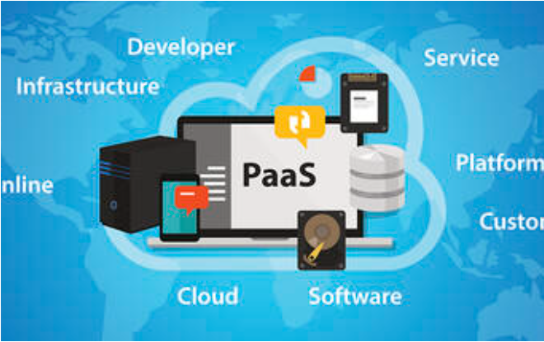

Software as a Service (SaaS):

It makes it possible for the users to connect to and use cloud-based application over the network (Microsoft Azure, 2023). It provides complete software that can be purchase on subscription based from any cloud service provider. All of the underlying infrastructure, middleware, app software and app data are managed by providers. It allows an enterprise to get quickly and work with an app at low cost (Microsoft Azure, 2023).

Benefits:

Usage Based Pricing:

The service automatically scales up or down depending on the number of user using the service (Microsoft Azure, 2023).

Freeware:

This service is already built and user only need to use it through the help of web browser, they don’t need to configure or install any other software (Microsoft Azure, 2023).

Mobilize workforce effortlessly:

SaaS, makes it easy for the users to access applications from anywhere through the internet. There is no any problem in running the application on any type of computer as that is already provided as a service (Microsoft Azure, 2023).

These are the benefits of Software as a Service (SaaS).

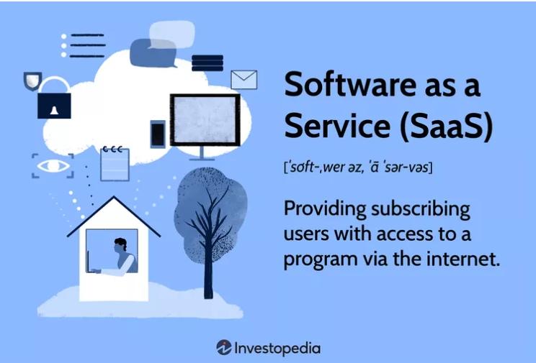

## Cloud vendors

There are many cloud vendors globally and among them top 10 are ranked with their regions and availability zones.

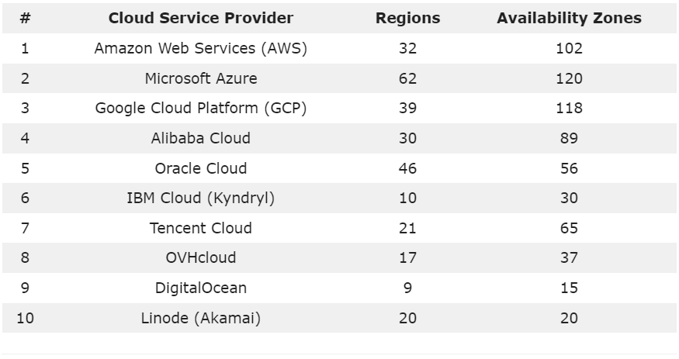

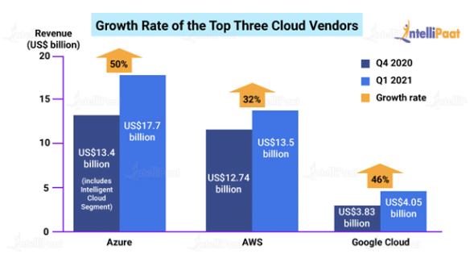

Amazon Web Services (AWS):

AWS stands out as one of the leading global cloud service providers, boasting a range of over 200 fully featured services delivered from its data centers (Zhang, 2023). At present, it operates in 32 regions and 102 availability zones, positioned across the world in areas of United States, Americas, Europe, Asia Pacific, Middle East and Africa (Zhang, 2023).

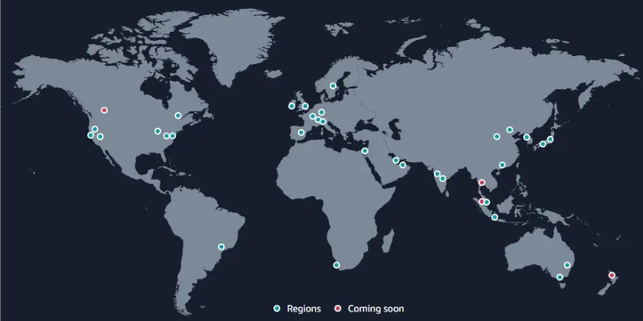

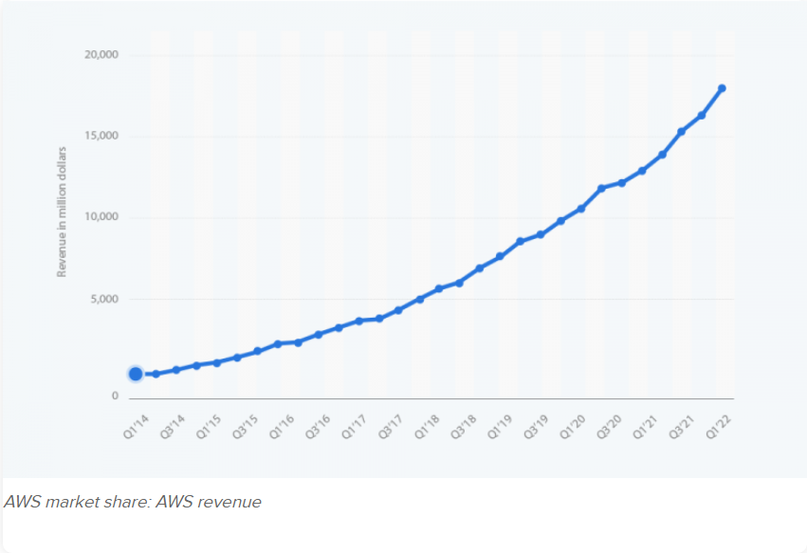

During ten years, AWS has a steep rise and its market share has increased more than 10 times. From the initial $4.6 billion in 2014 to over $18 billion in 2022, The market share has grown massively as the revenue (Rahul, 2023). It been forecasted that IaaS is expected to witness substantial increase in end-user spending, with growths by 30.6%. In comparison DaaS will grow by 26.6% and PaaS by 26.1% (Rahul, 2023).

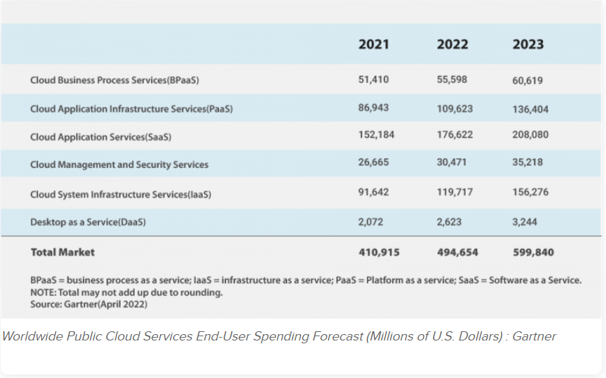

AWS is used by: Coursera, Intuit, Expedia, Airbnb, Netflix, Lyft, Coinbase, Coca Cola (Coursera, 2023)

Microsoft Azure:

As the second largest cloud service provider worldwide, it ensures a consistent hybrid cloud experience, boost developer productivity, offers artificial intelligence capabilities and prioritizes security & compliance (Zhang, 2023). With 62 regions and 120 availability zones, these services are distributed across the US, Americas, Europe, Asia Pacific, Middle East and Africa (Zhang, 2023).

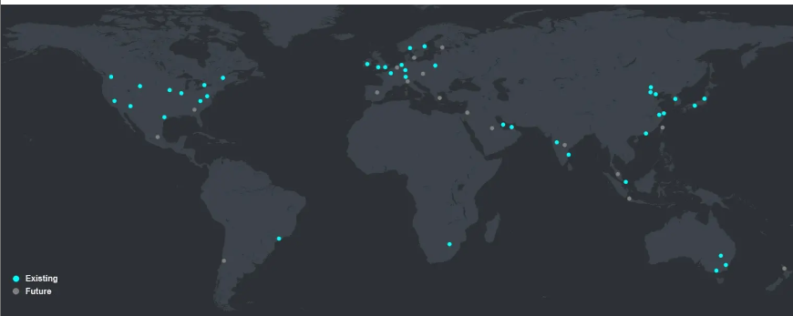

In 2023 its market share is 23%, it increased by 2% from 2022, Microsoft doesn’t provide its azure sales figures instead it combines with other services under its Microsoft intelligent Cloud Umbrella (Haranas, 2023). This group generated $24.3 billion in sales.

Microsoft Azure is used by: Audi, ASOS, HSBC, Starbucks, FedEx, Walmart (Coursera, 2023).

Google Cloud Platform:

Google Cloud Platform holds the third largest global cloud service provider. It offers cloud service tailored for enterprises (Zhang, 2023). It empowers developers to create, test and launch application on its infrastructure, additionally user can also utilize its feature in security, data management, analytics, and AI (Zhang, 2023). This platform spans 39 regions and 118 availability zone, across the US, Americas, Europe, Asia Pacific, Middle East and Africa (Zhang, 2023).

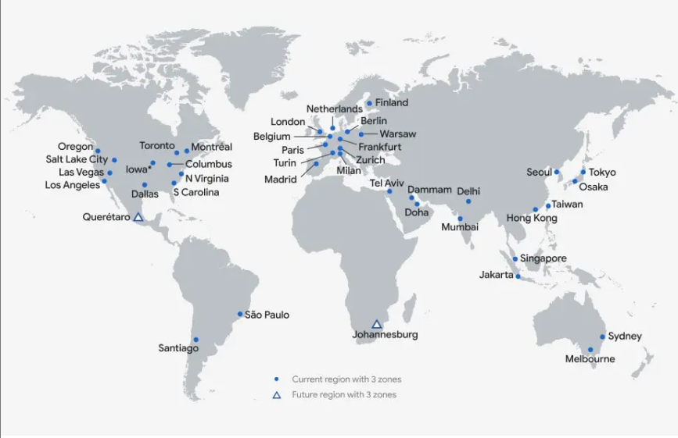

Similarly, for google cloud, its market share has remained stable in 11% from 2022 to 2023, Google cloud is experiencing raid sales growth, with a year-over-year revenue increase of 22%. In 2023, the total revenue generated by it reached $8.4 billion (Haranas, 2023).

Google Cloud Platform is used by: Toyota, Equifax, Nintendo, Spotify, Twitter, PayPal (Coursera, 2023).

## Critical Review

Amazon Web Services (AWS) is best at providing the infrastructure service which includes scalable storage, networking, server, mobile development and cybersecurity solutions (Coursera, 2023). Microsoft Azure offers one of the best scalable and efficient software solution while Google Cloud Platform (GCP) specializes in advanced big data analytics solutions and facilitates seamless integration with products from other cloud vendor (Coursera, 2023).

AWS vs. Azure vs. Google Cloud: the key difference

In figure 1, basic differences are shown,

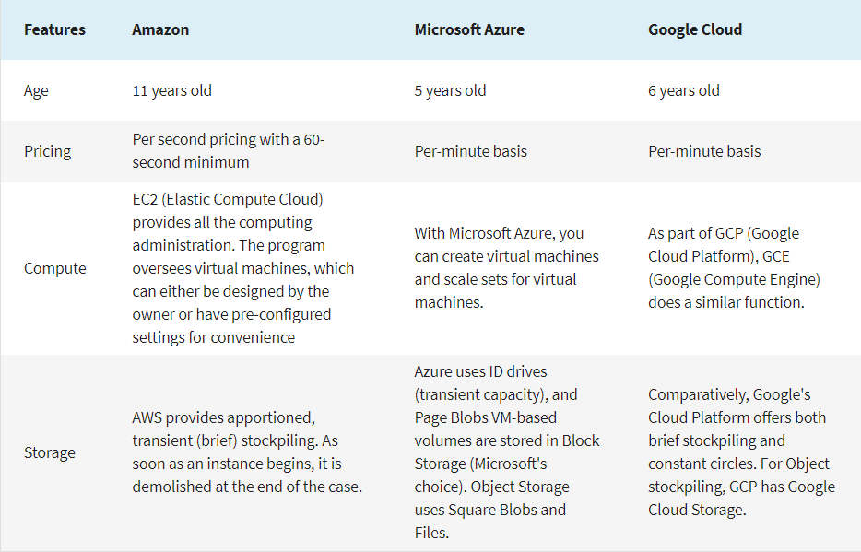

*Figure:1*

AWS entered the public domain in 2006, introducing services like EC2 and Amazon S3. As being one of the early cloud businesses, it has an extensive user base and great trust and reliability (Coursera, 2023). Google cloud launched in 2008, and it has solidified its position in cloud business. Microsoft Azure established in 2010 to offer enterprise with robust cloud computing platform (Coursera, 2023). When choosing a cloud provider, user should consider the regions and availability as things like latency, compliance regulation and data which can have direct influence on cloud.

In figure 2, Each platform computational capabilities individually are shown,

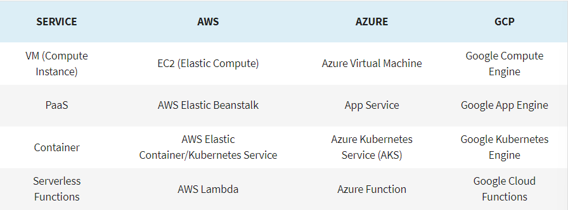

*Figure: 2*

Compute describes how computers works, and is one of the important factors, when looking into these three-cloud provider (Coursera, 2023).

In figure 3, the pricing structure are shown based on machine type each provide,

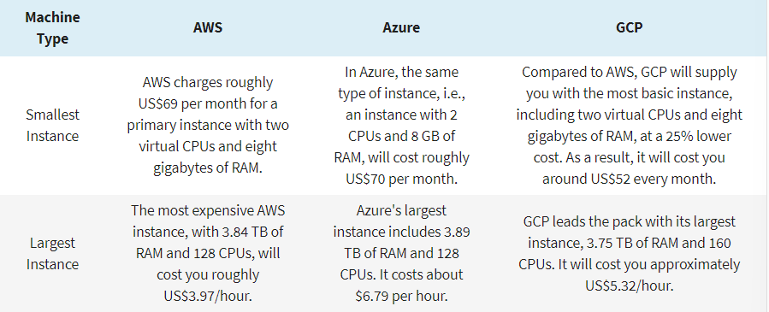

*Figure: 3*

The general consensus within the community is that Microsoft Azure offers the lowest on-demand cost, Amazon positioned in the middle. These three systems provide user with price plans and extra cost control feature which are largely influenced by customer specification, usage and the service utilized (Coursera, 2023).

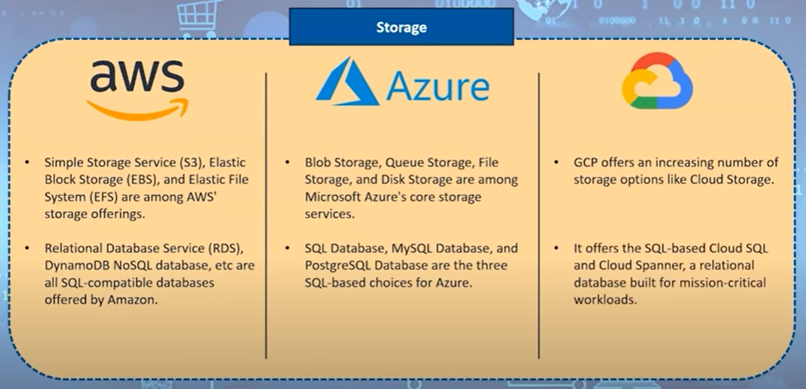

Here all this figure shows the difference in cloud services and when a enterprise or user want to use any cloud service, they need to look at their requirement before choosing the cloud service.

For example,

If an enterprise wants to build an ecommerce web application, they can choose AWS to host it, using services like EC2 for computing power, S3 for storing images and files and RDS for managing the relational database. The diverse and scalable services of AWS will help this site to handle traffic holds which will make good experience for customer.

If an enterprise wants to perform advance analytics and use machine learning models on huge data sets then Google Cloud will provide services like Big Query to analyze these datasets quickly and efficiently. Its strength in data analytics and ML makes it the best choice for deriving insight from large datasets.

If an enterprise wants to go from on premise to cloud then Microsoft azure is the best option, as it offers hybrid cloud and robust integration capabilities. Azure virtual machines can be used to extend the on-premise servers to cloud. Its emphasis on integration makes it best choice to companies having complex IT system.

## Specification

In this report, the web service was deployed in AWS Elastic Beanstalk, so the used Cloud Provider is AWS while the service is Elastic Beanstalk. The reason to select AWS as service provider is due to its availability, even though it is complex due to many services as AWS is one of the first cloud business there are lots of material like tutorial and reports online to take reference from and learn. AWS also provides me with the facility of automatically scaling my application up if number of user increase while scale down of number of user decrease.

Elastic Beanstalk was used as service because, configuring elastic beanstalk is easy. The application can be developed in local machine and creating a jar file or a zip file, the application can be easily deployed. If there was change in application, simply the application can be uploaded and deployed again causing the version change. It also doesn’t waste any time in undifferentiated heavy lifting and doesn’t consume lot of time and as this project is simple project so, Elastic Beanstalk was used.

# Development and Deployment

## Development

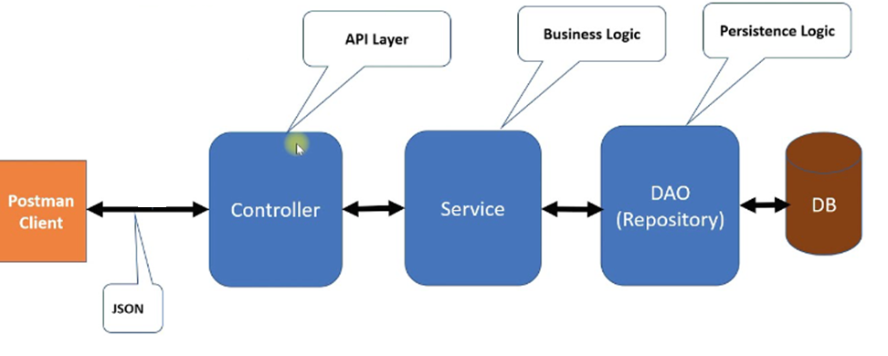

This is spring boot application architecture, here we have a controller, who has API layers, service, who has Business Logic and DAO which has persistence logic and a PostgreSQL DB. Here user can access the URL and either add product, see the products, delete the product, add the product to cart or remove the product from cart. There is a local client to run these but the local client is not deployed so Postman is used for testing to check if it is working.

The API is hit using postman and we can see the API return data in form of Json.

In this web application there is a local client side, server side and a database. The local client is not deployed while server and database are deployed. Testing of API is done using postman.

Client Side:

Local client side created using react.

Add product

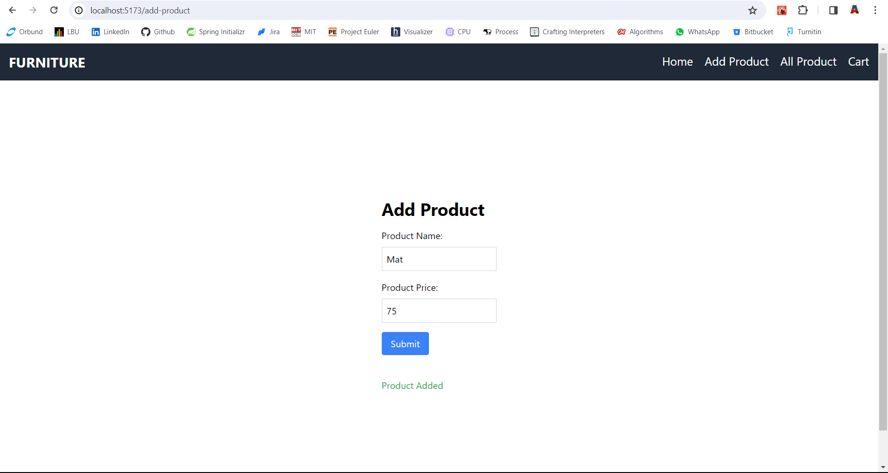

See the added product

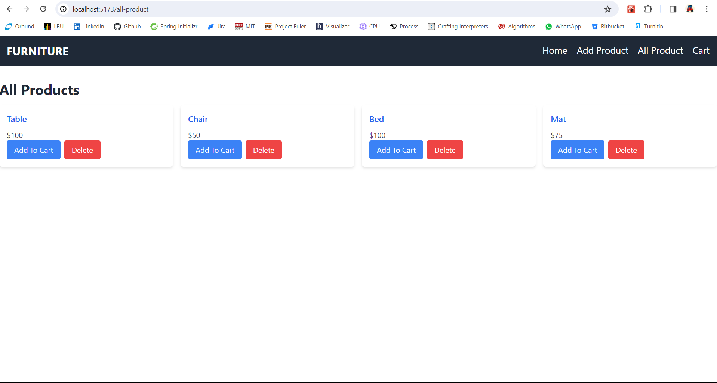

Product added to cart

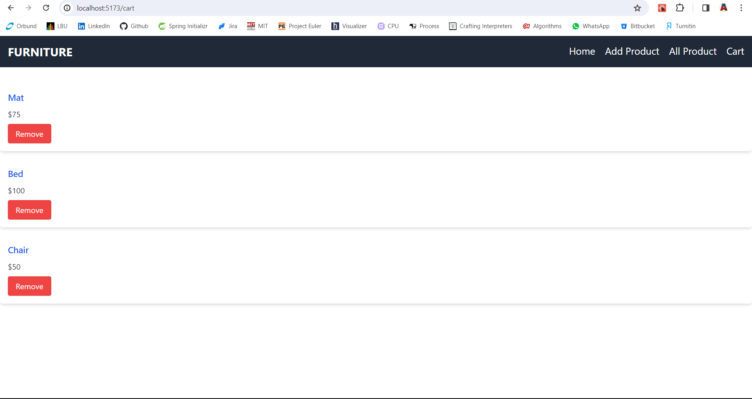

Product removed from cart

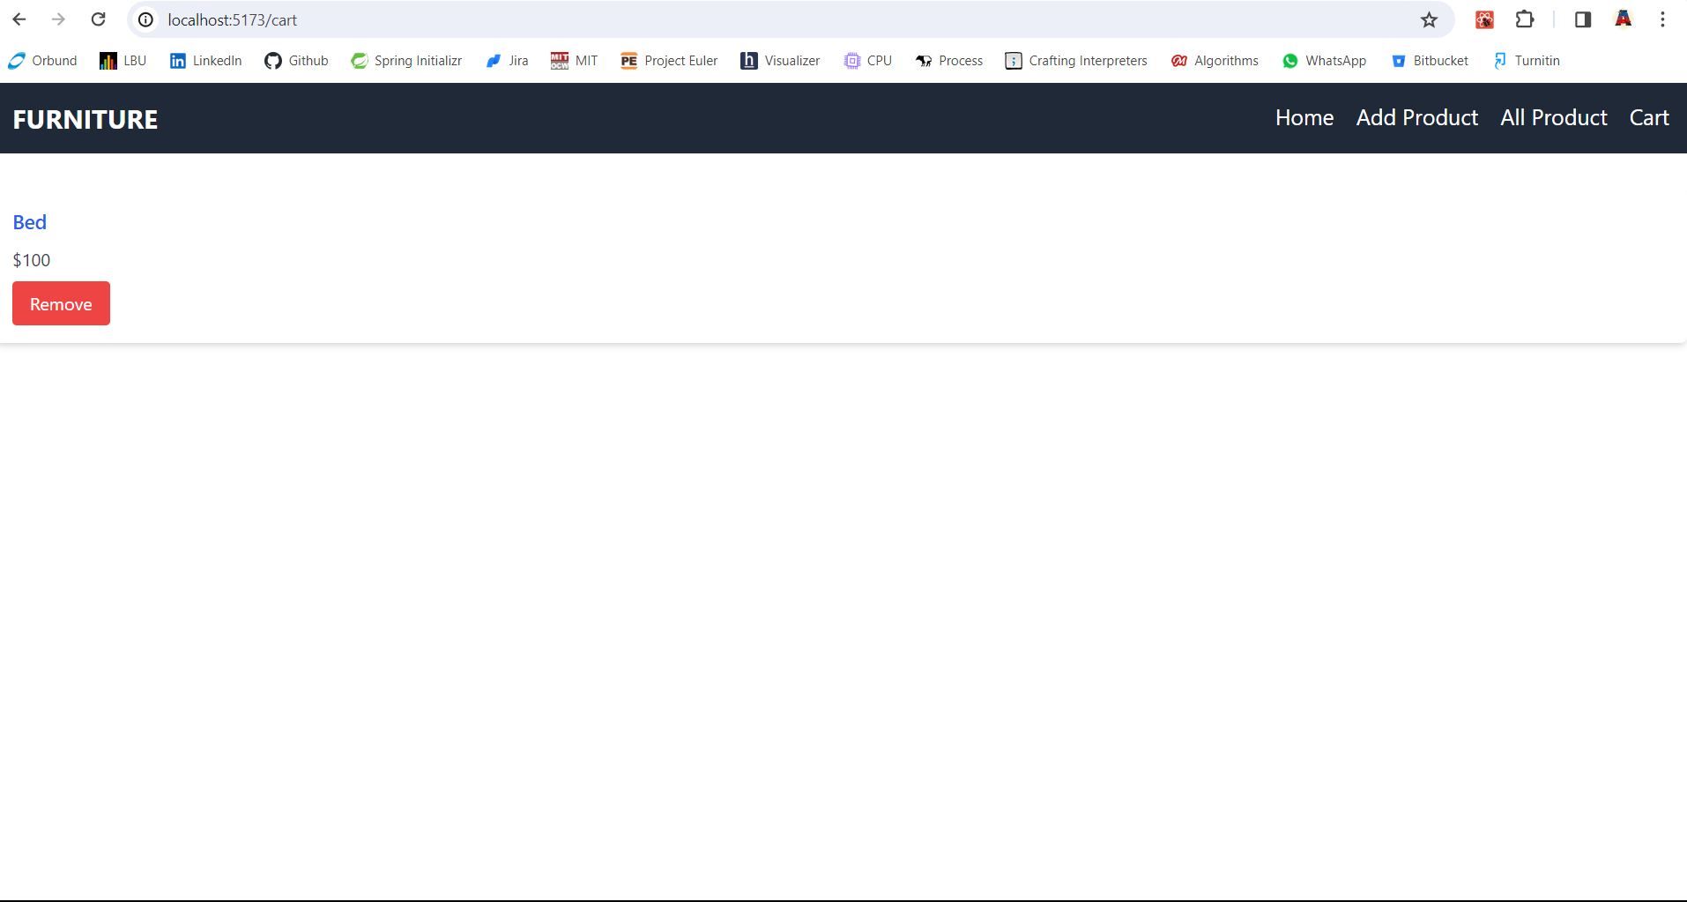

Product deleted

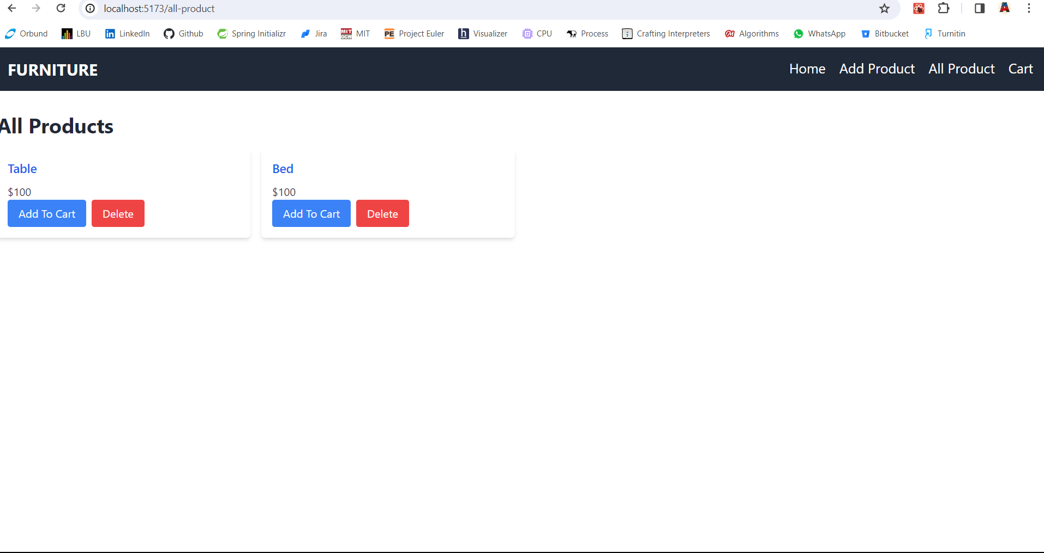

Here this is how the local client side is connected with backend.

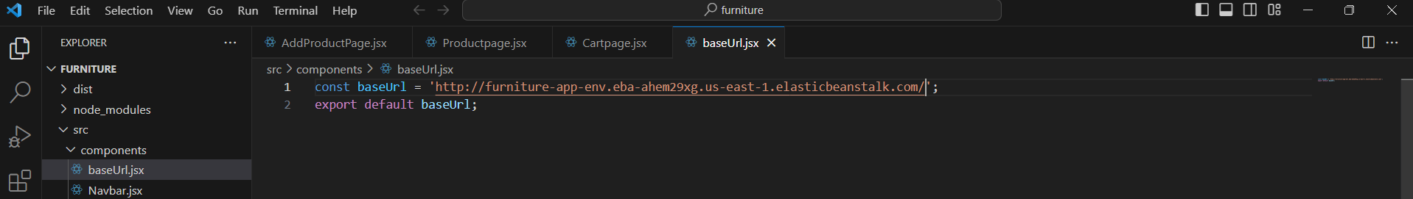

Server Side:

Server Side was created using spring boot. Uses dependency like data jpa, spring web, Lombok and PostgreSQL driver, here only some portions of pics are shown. Server side has 3 entities, Product, Cart and a linked entity cart-item. It has controller, service, repository and model for all this entity. The service contains crud operation for all three entities.

Spring boot was used because of the ability to manage dependency easily. Able to create a secure API, Easy to make server side as it has less configuration which save a lot of time.

Rest controller OF product entity having API.

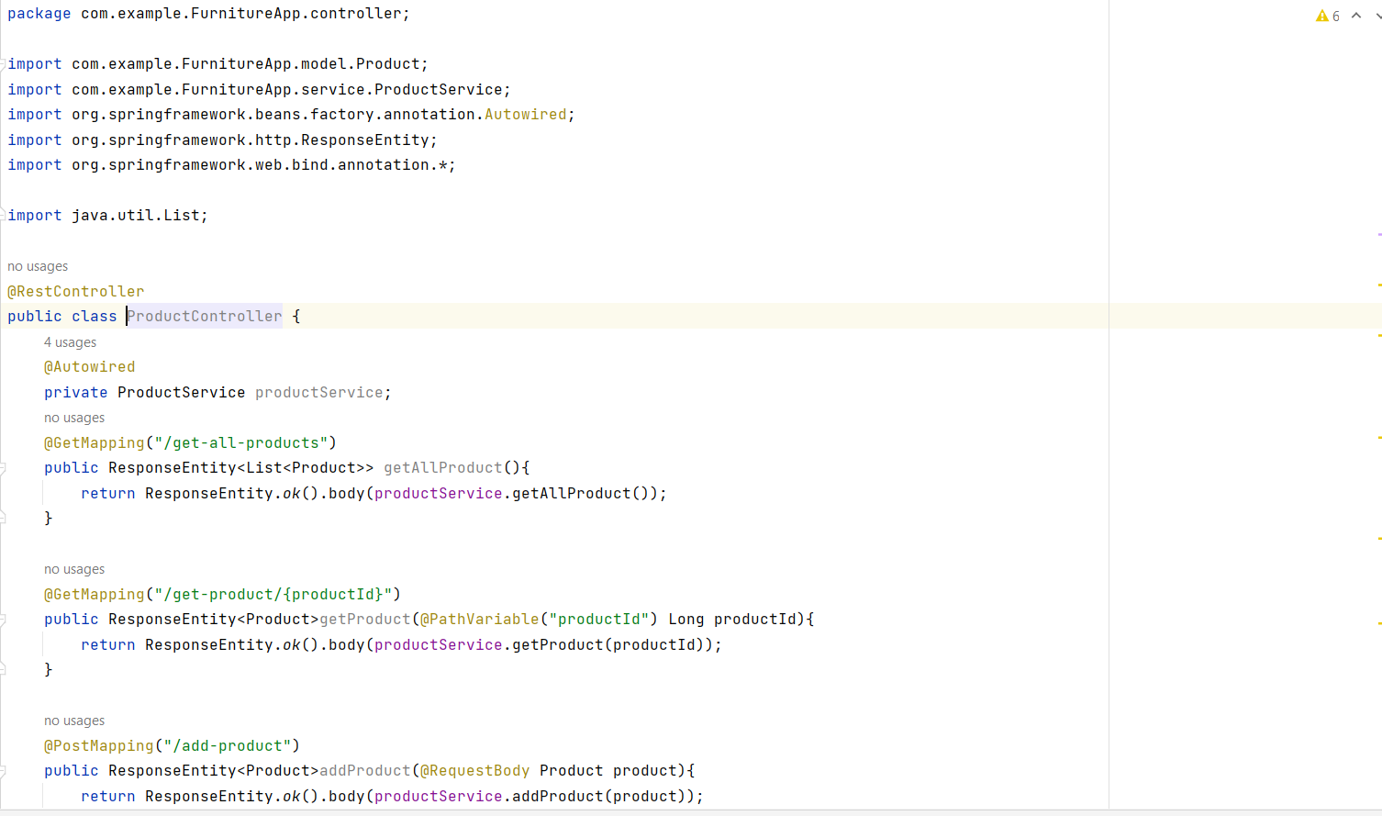

Model for product entity

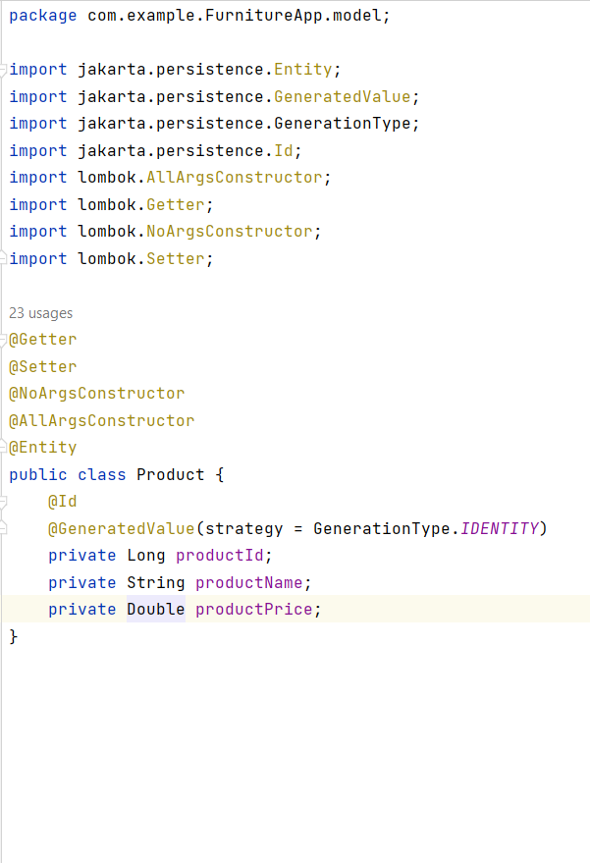

DAO for Cart Item Entity

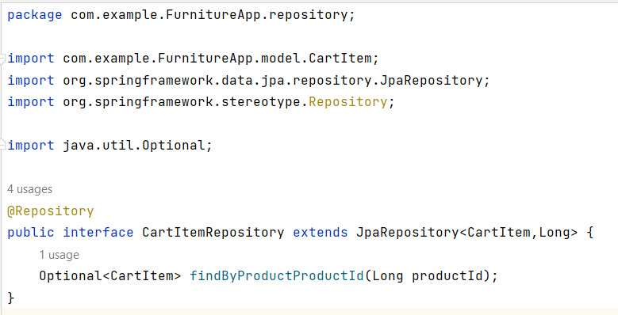

Service for cart entity.

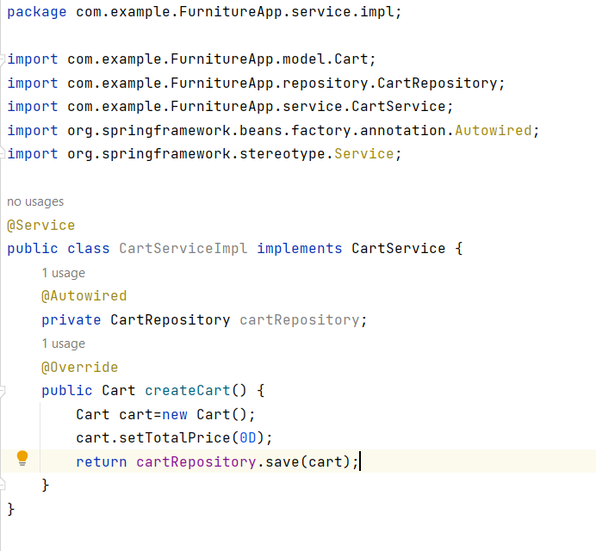

Database Side:

The database for this webservice is create using AWS RDS Service. The database used is PostgreSQL, all the SQL command are handled by ORM Framework (hibernate).

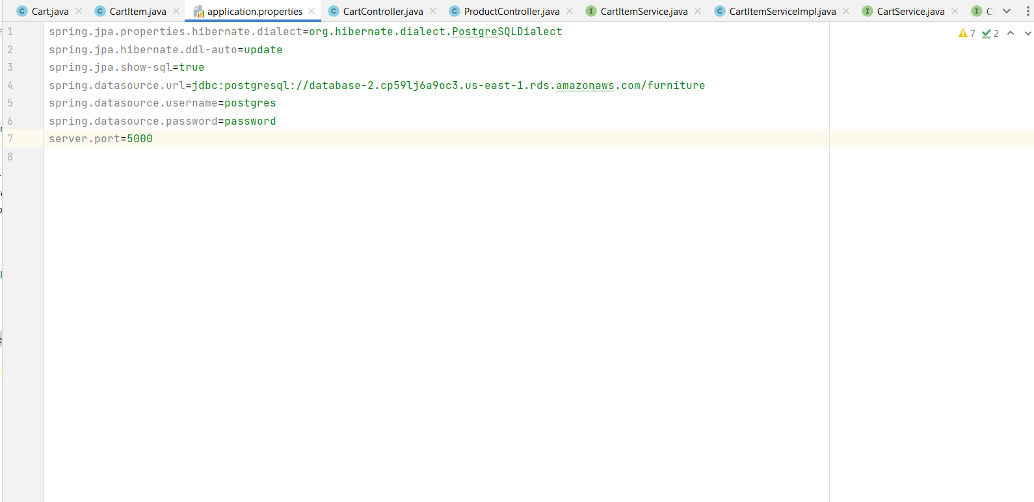

This is how server side was connected with database

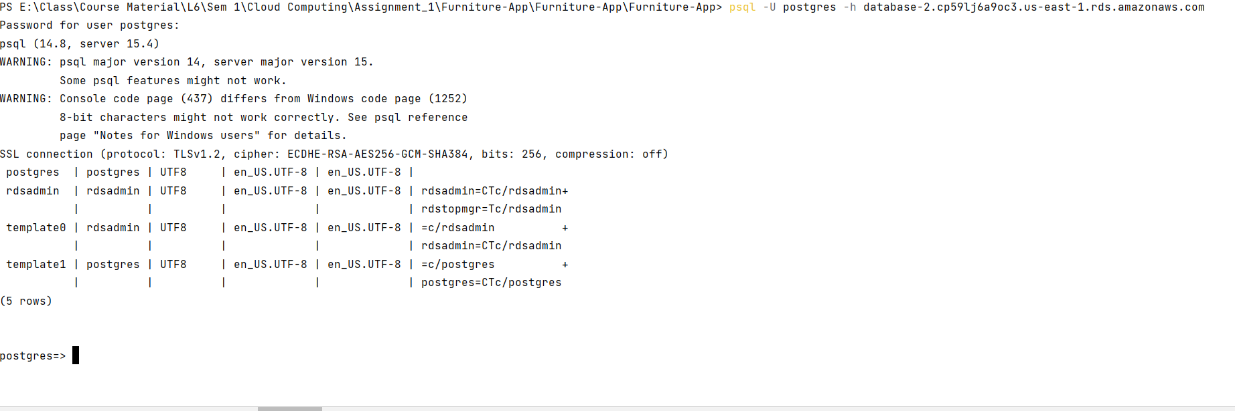

Creating new database called furniture

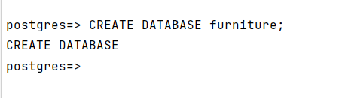

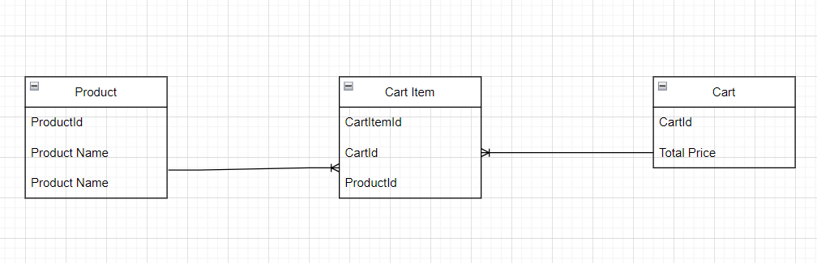

Entity Relation Diagram (ERD) for database

## Deployment

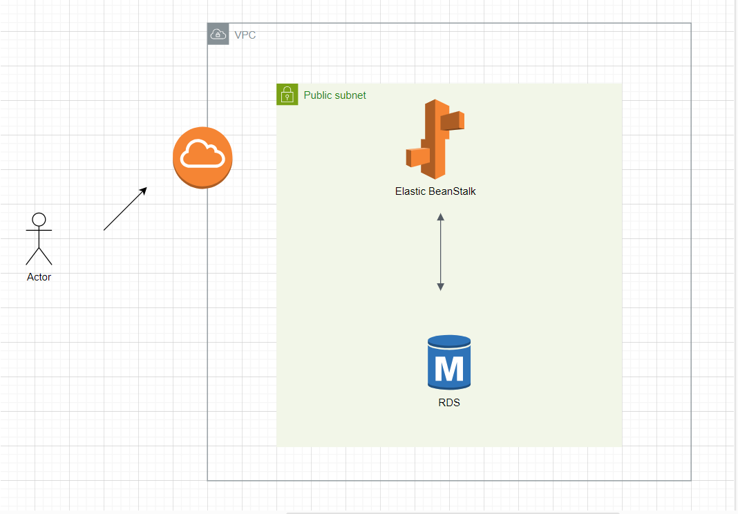

Here, default VPC was used and in the public subnet of the VPC, a RDS service and Elastic Beanstalk service was created. Here the application in deployed in elastic beanstalk is connected to RDS and there is two-way communication between them.

Developmental Step of RDS:

1. Find RDS Service

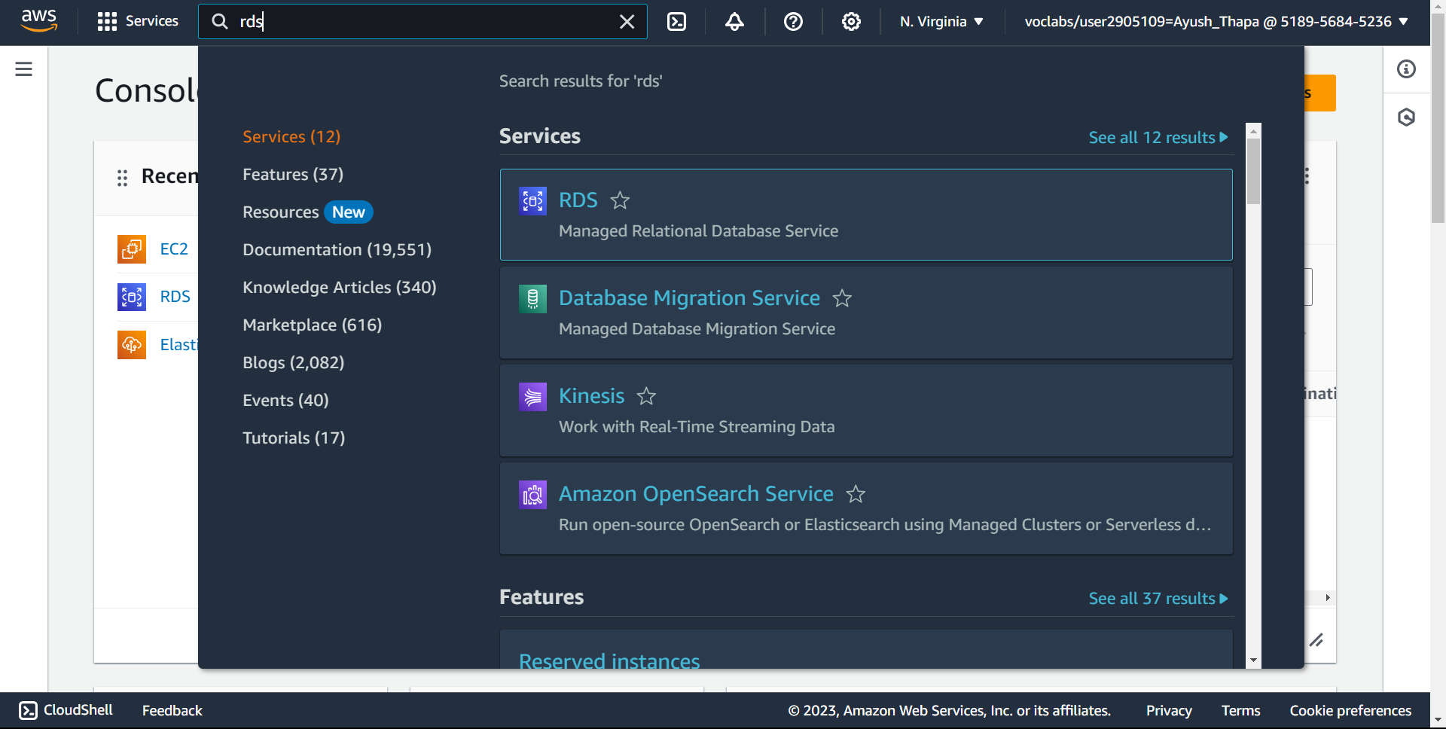

1. Create Database

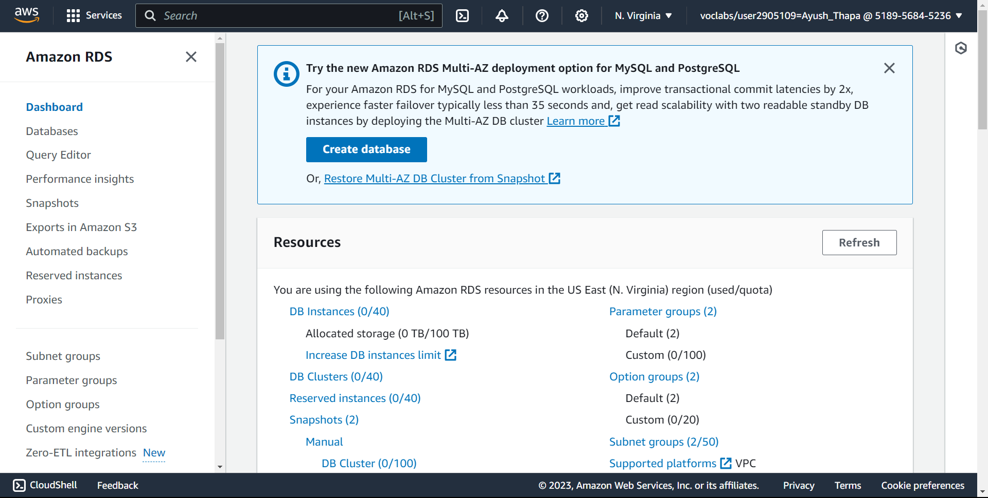

1. Standard create option

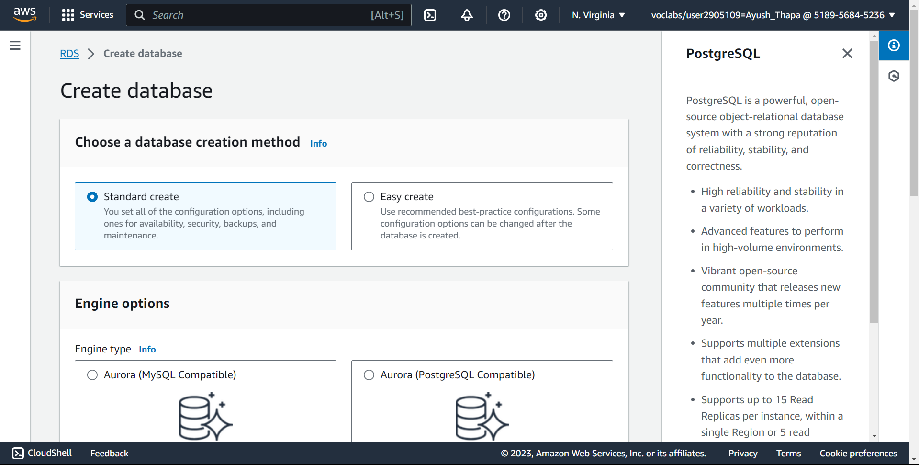

1. PostgreSQL Database

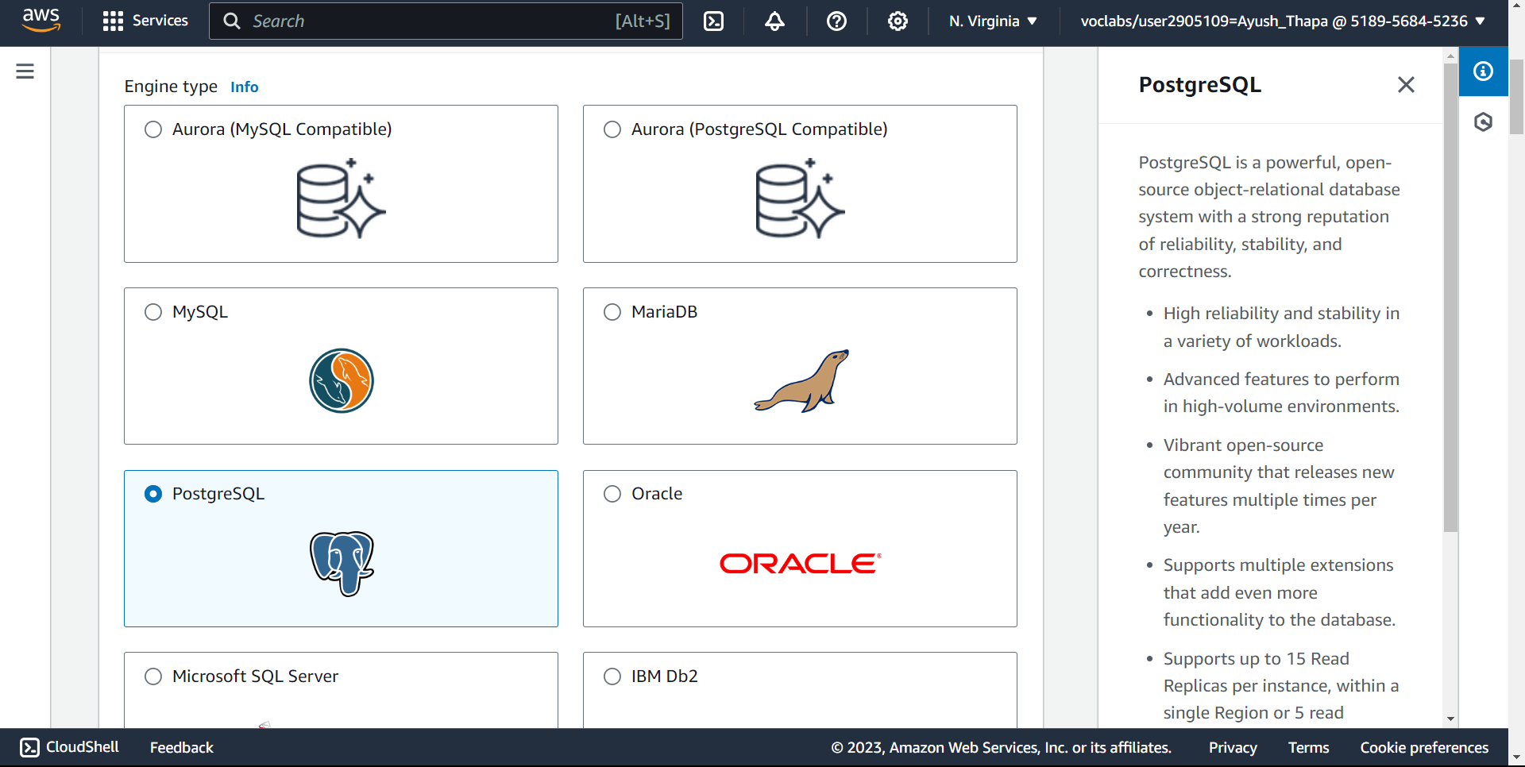

1. Free Tier

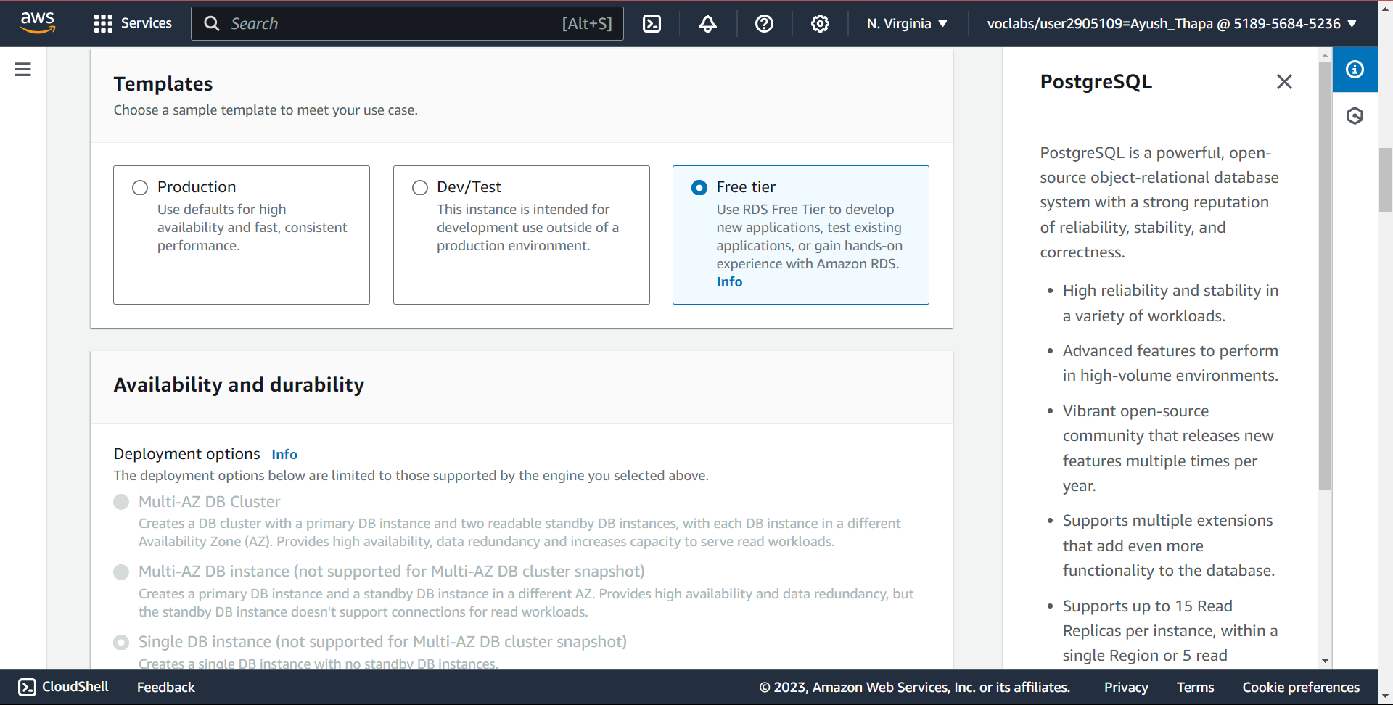

1. DB name and username

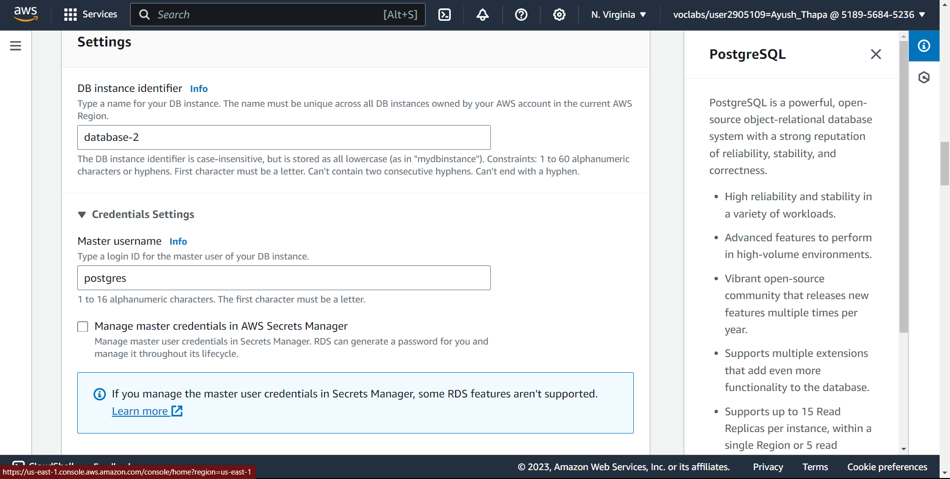

1. DB Master password

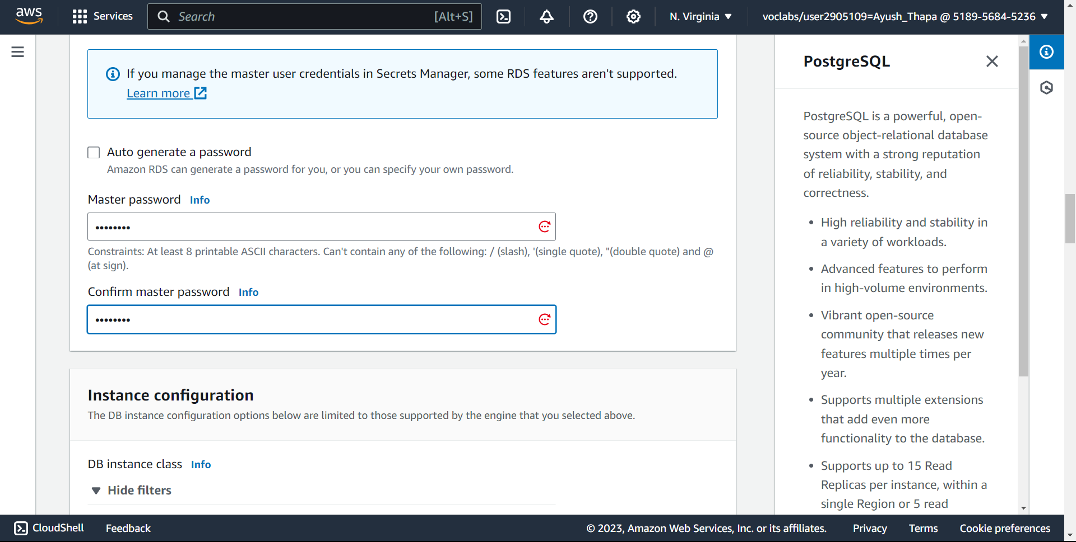

1. Using default VPC and public subnet

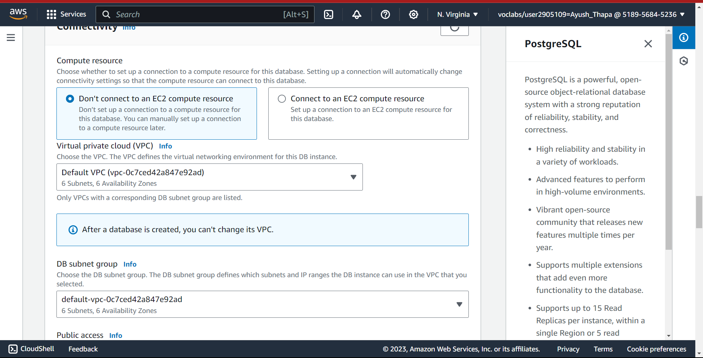

1. Turn on public access

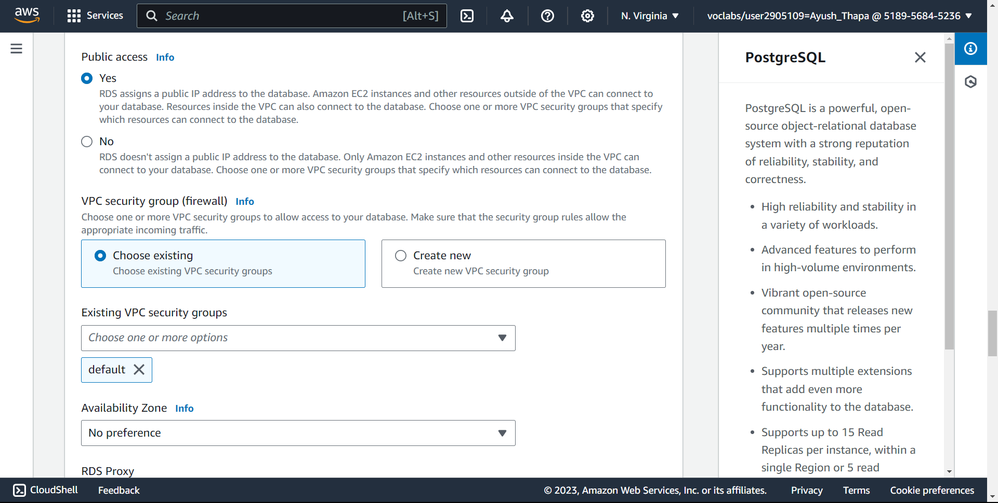

1. Creating Database

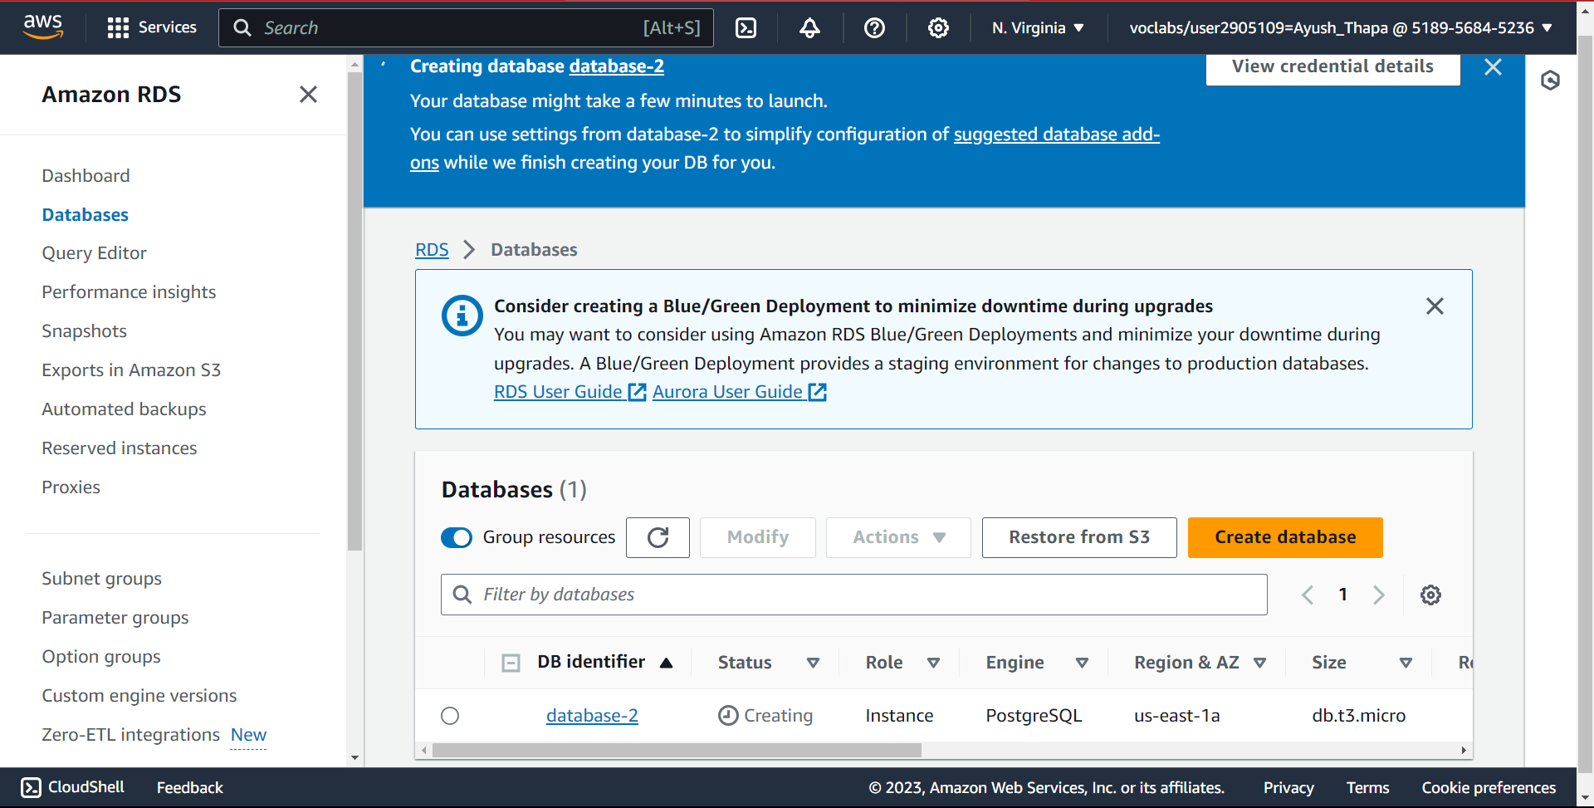

1. Database Created

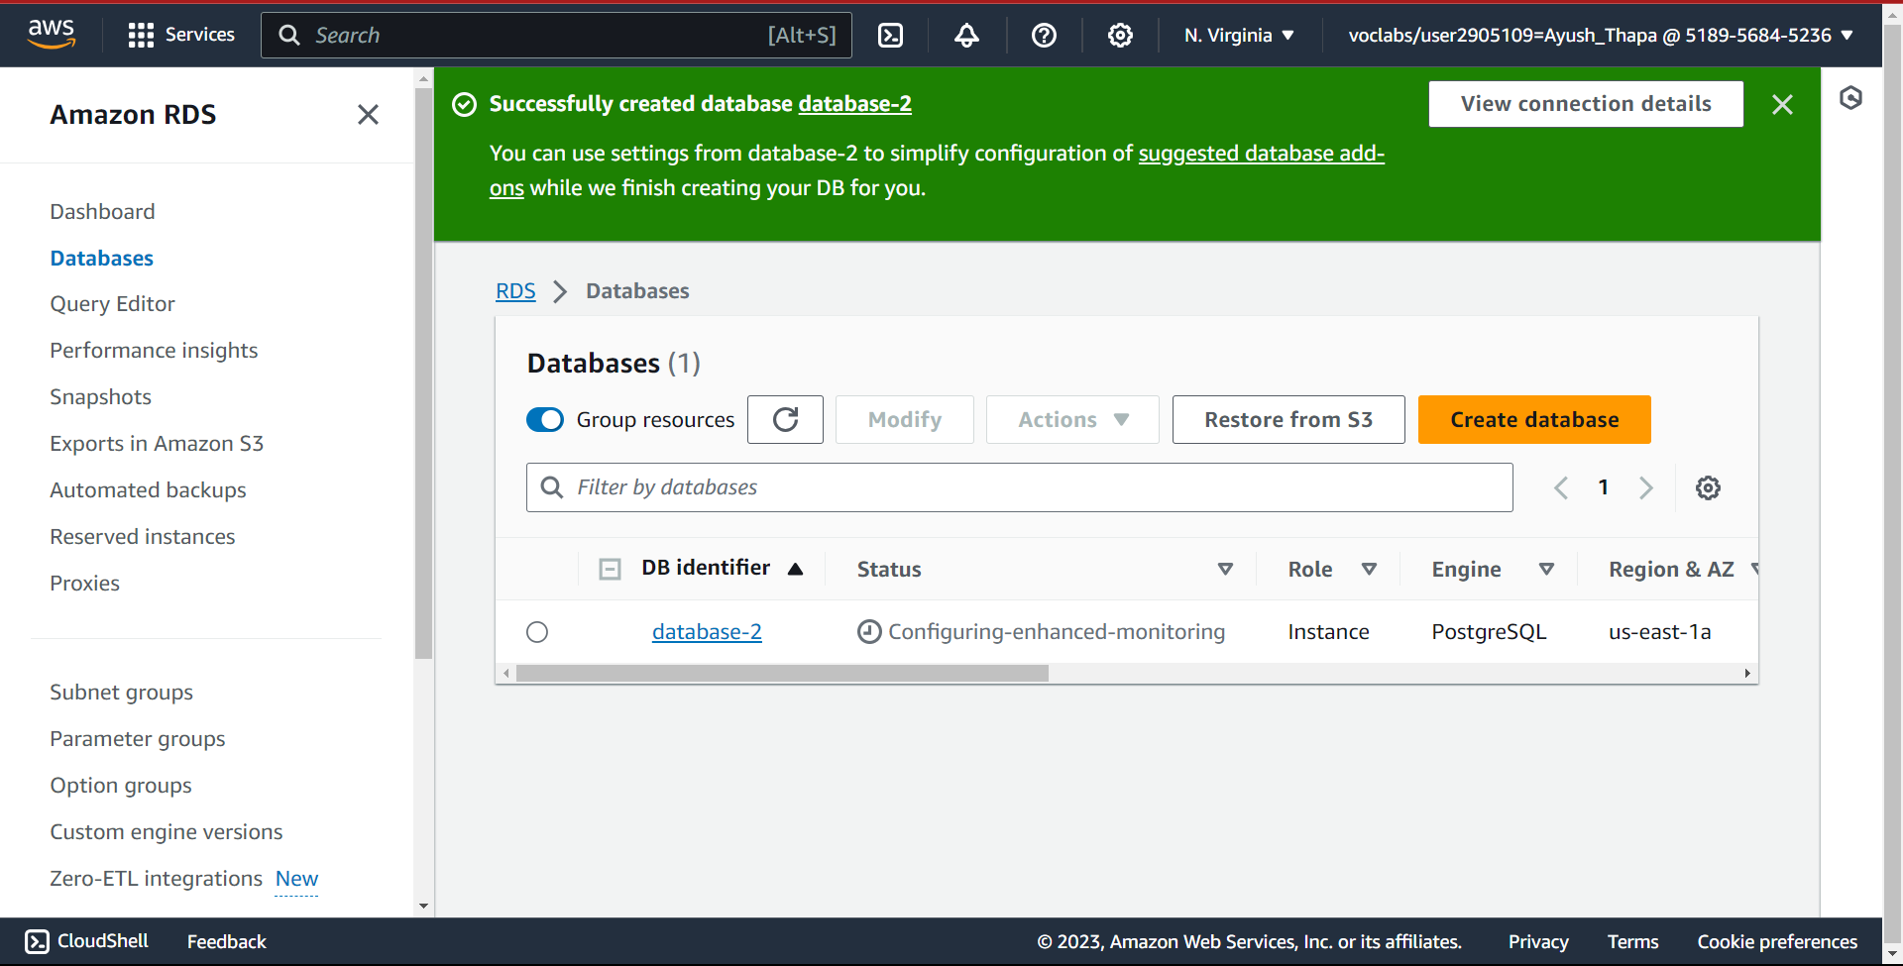

Developmental step for creating Elastic Beanstalk:

1. Find Elastic Beanstalk

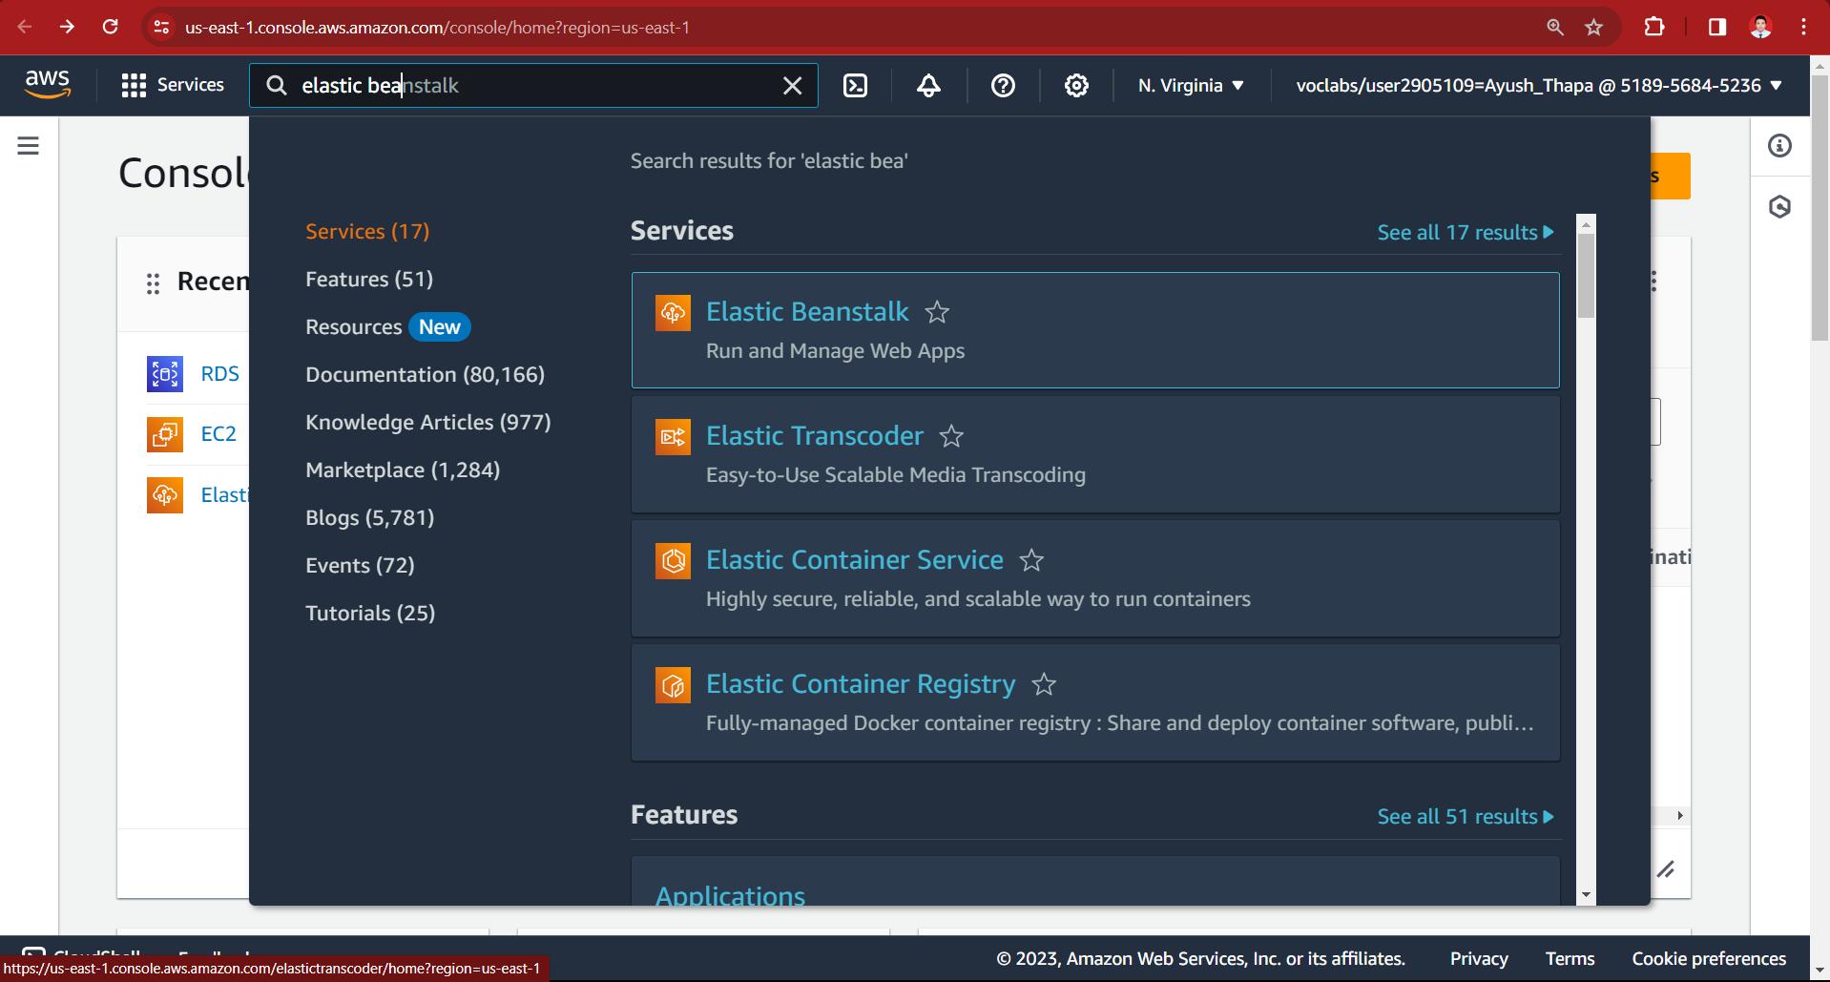

1. Create Elastic Beanstalk

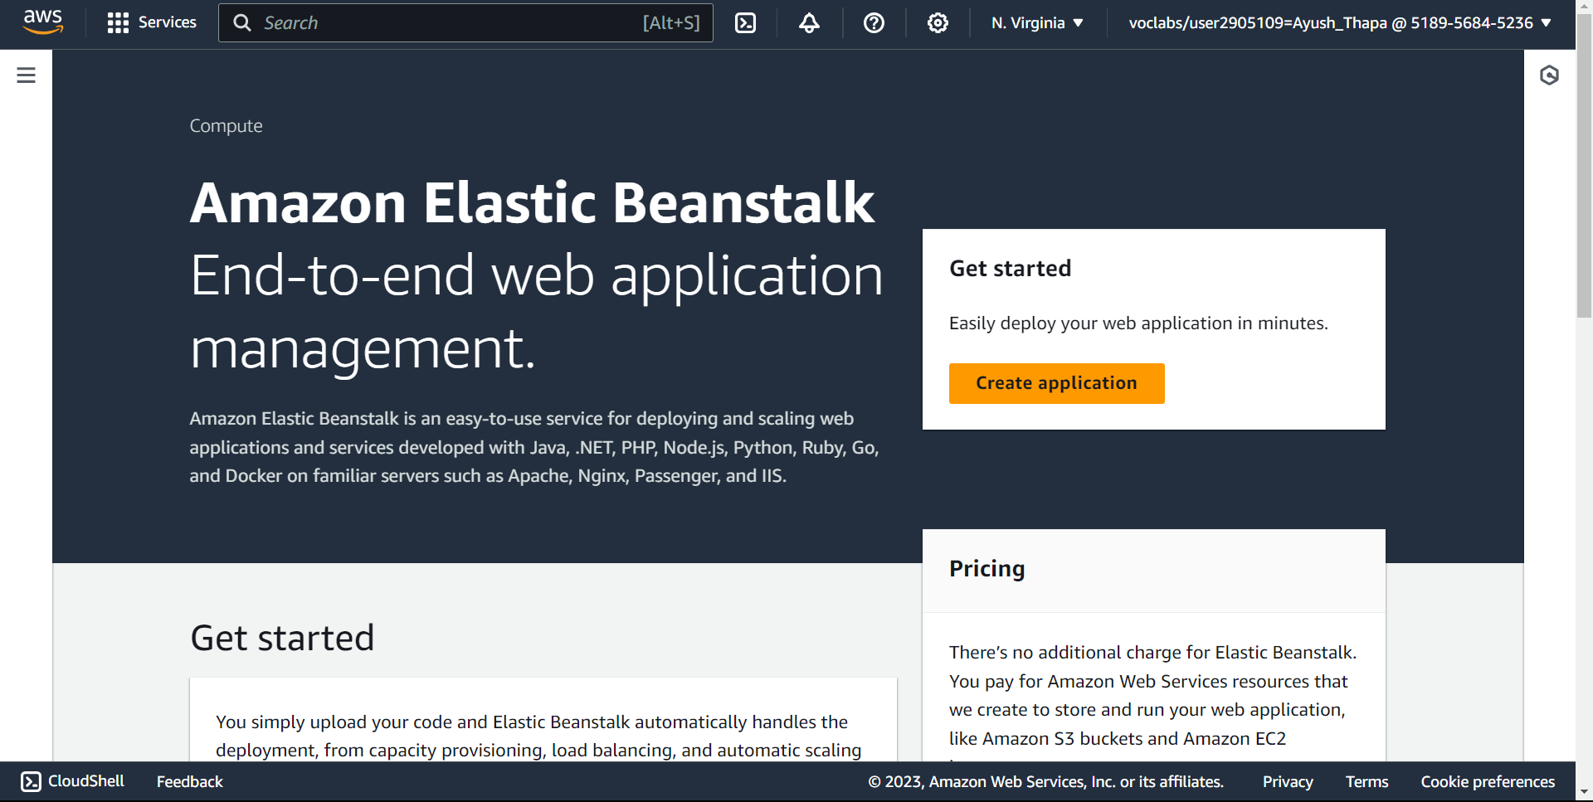

1. Configure environment and application name i.e. furniture-app

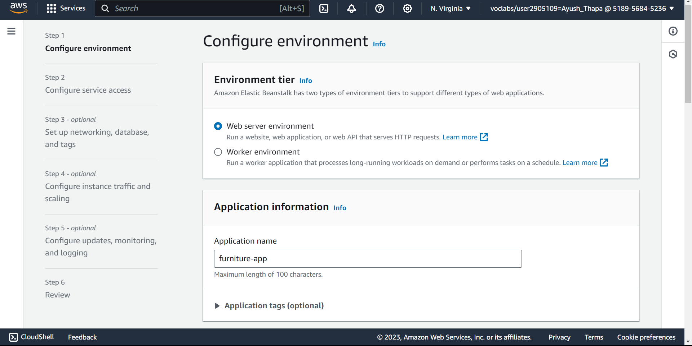

1. Platform, as application is built in spring boot, we choose Java

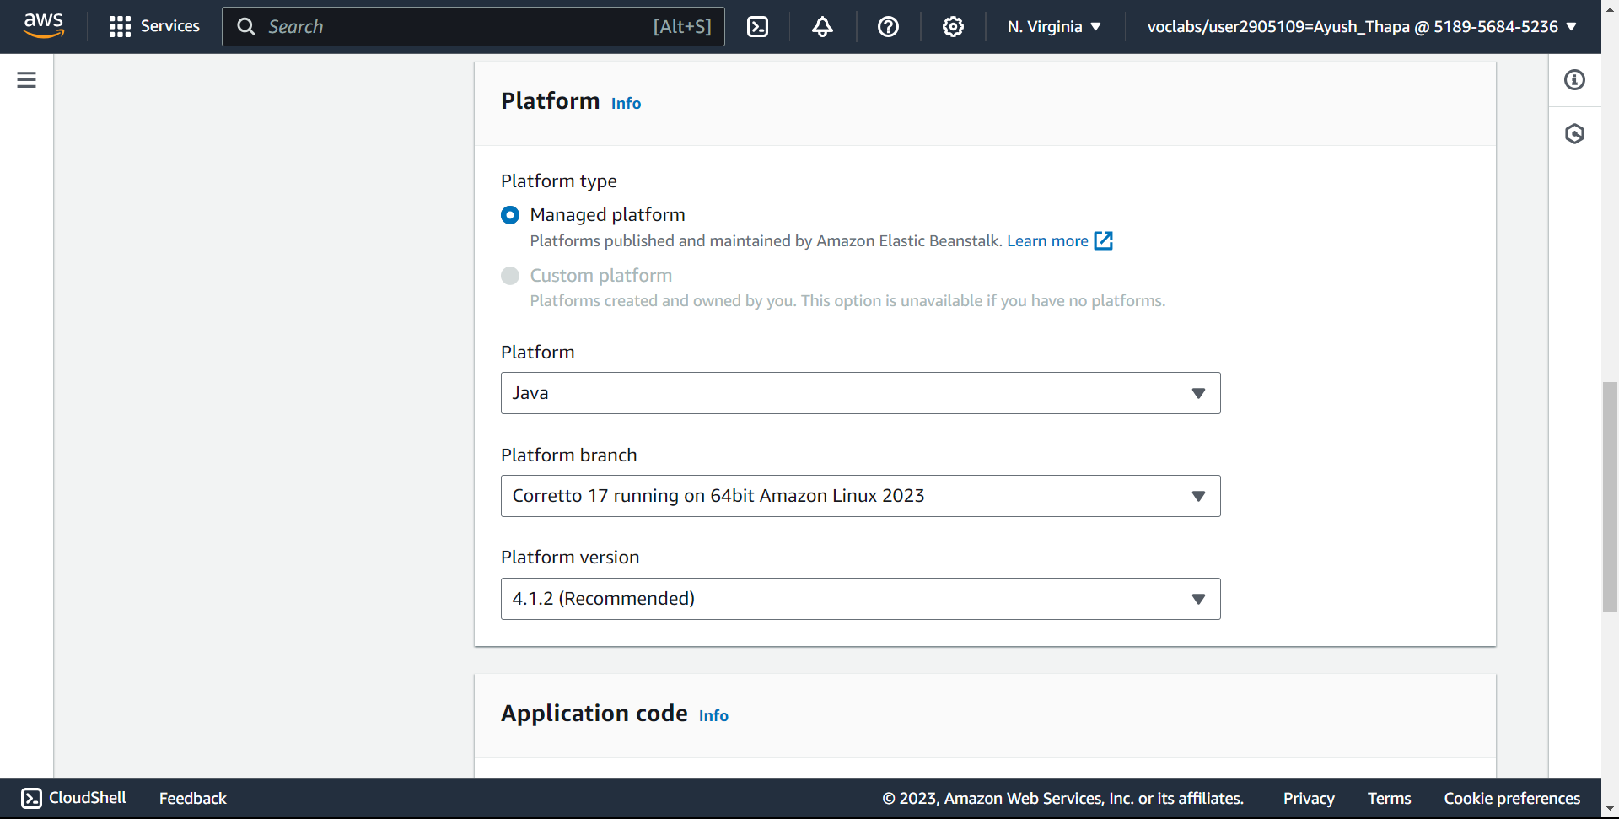

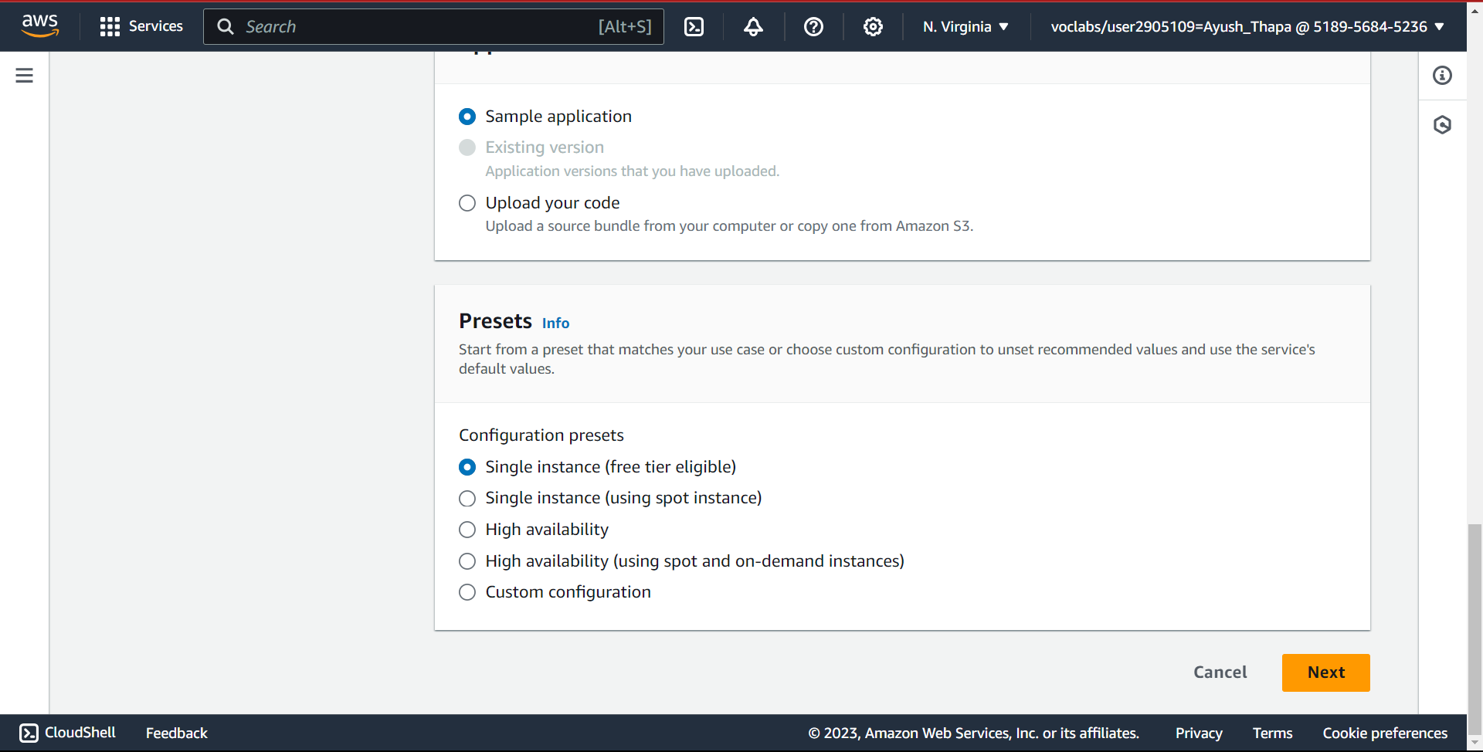

1. Default service roles

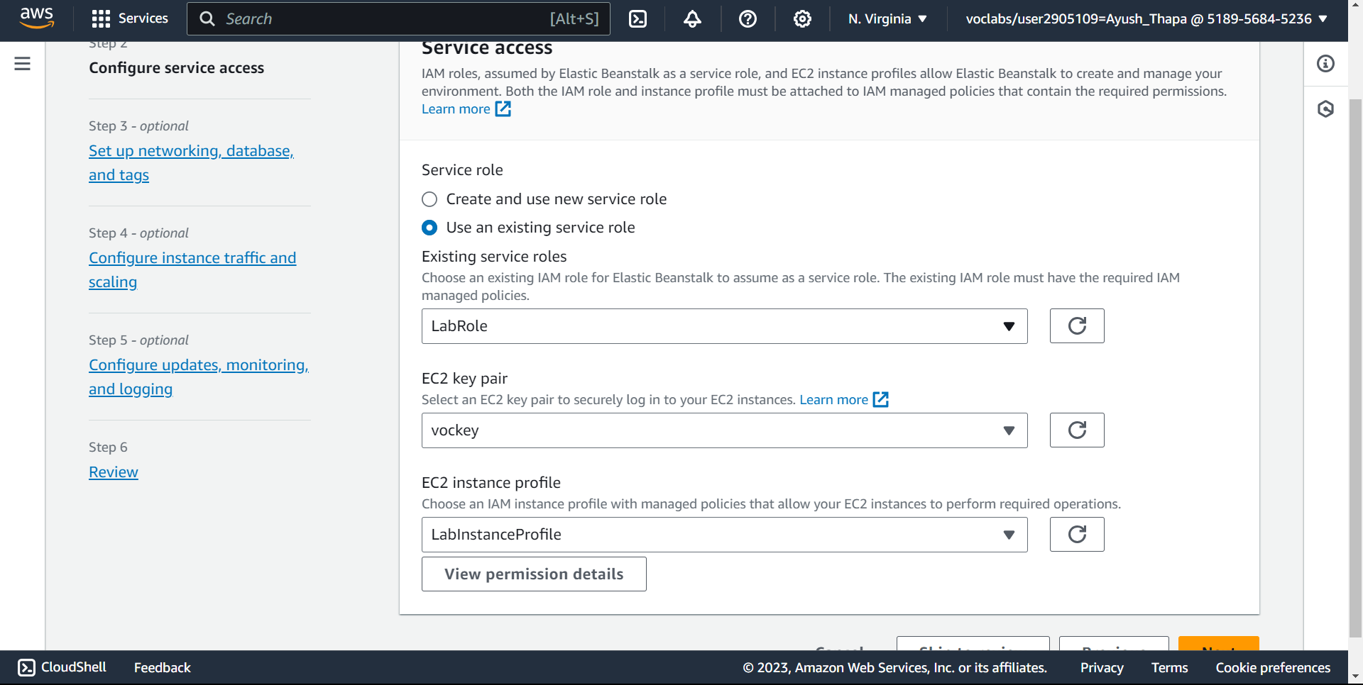

1. Default VPC

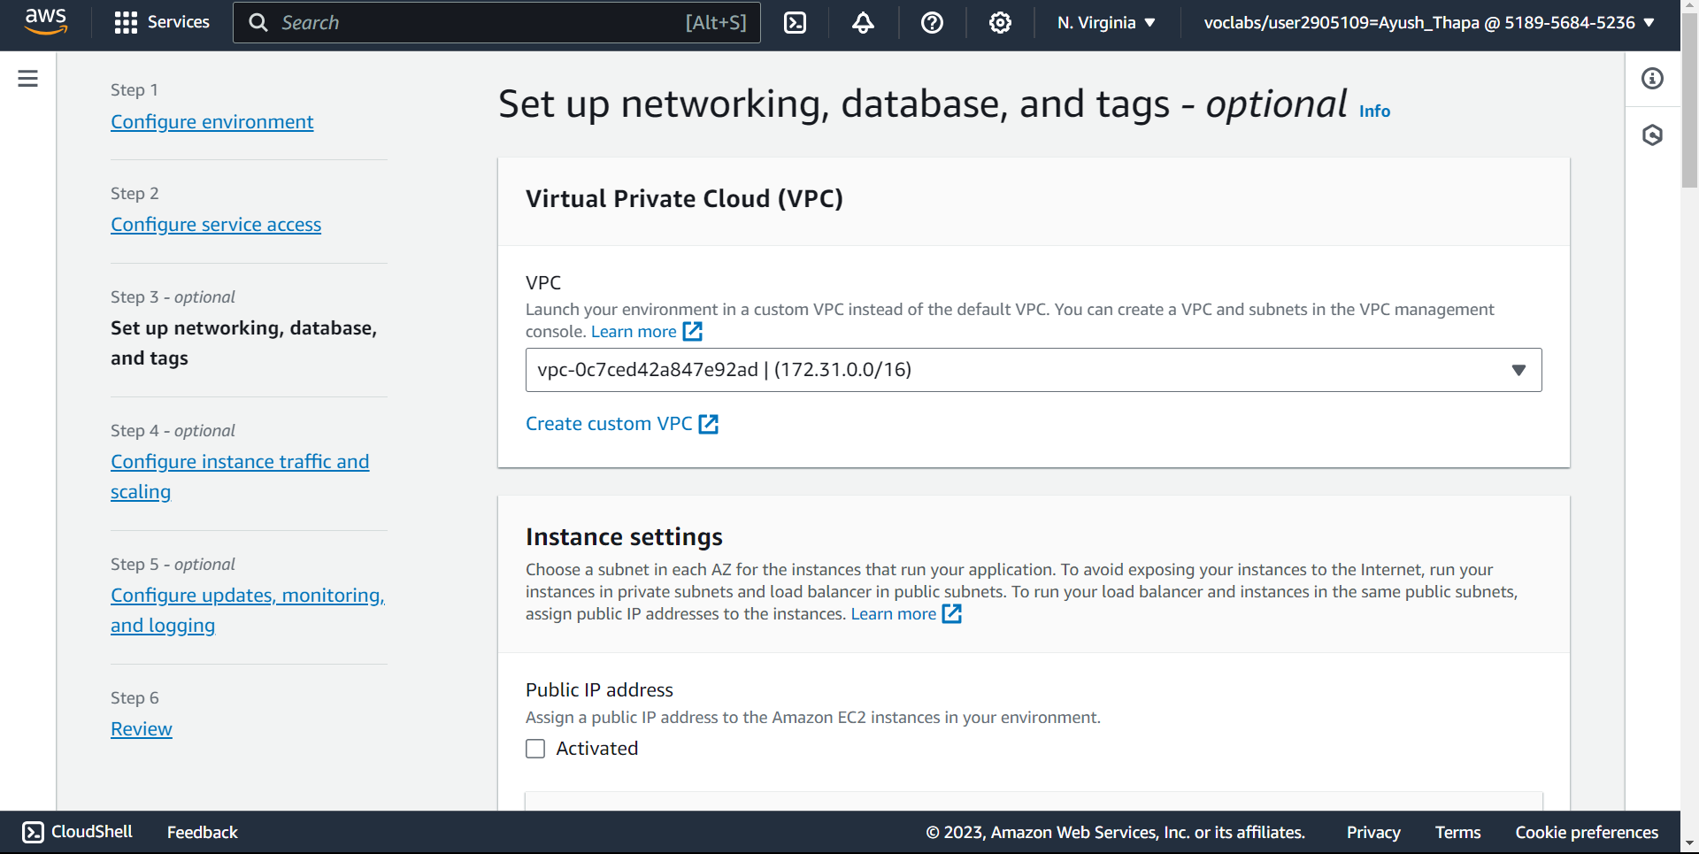

1. Activate public IP address and two instance subnets

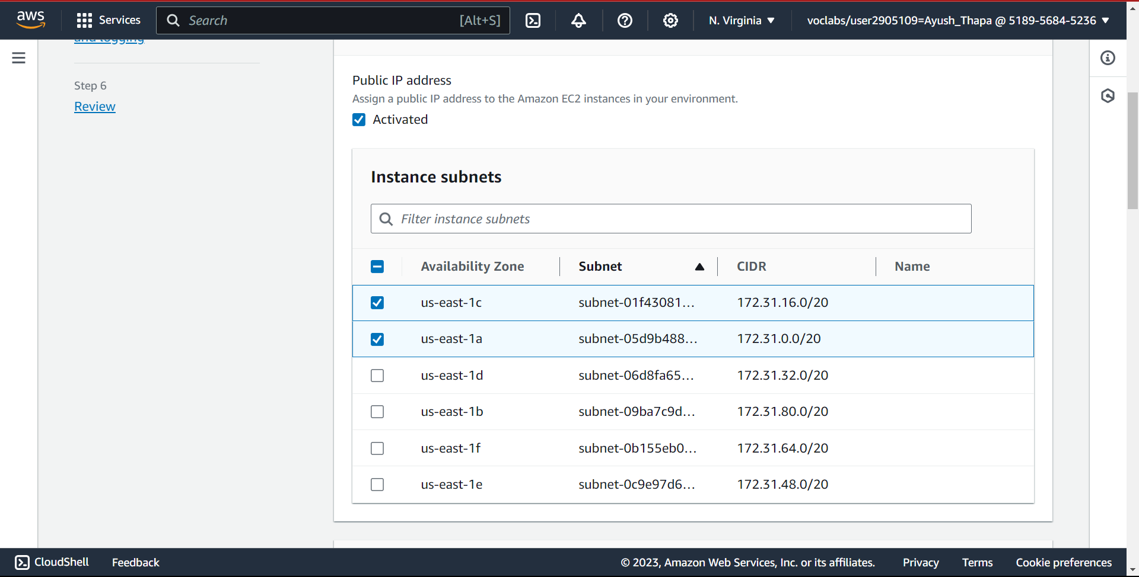

1. Click on skip to review and create
2. Upload the jar file created using mvn clean install

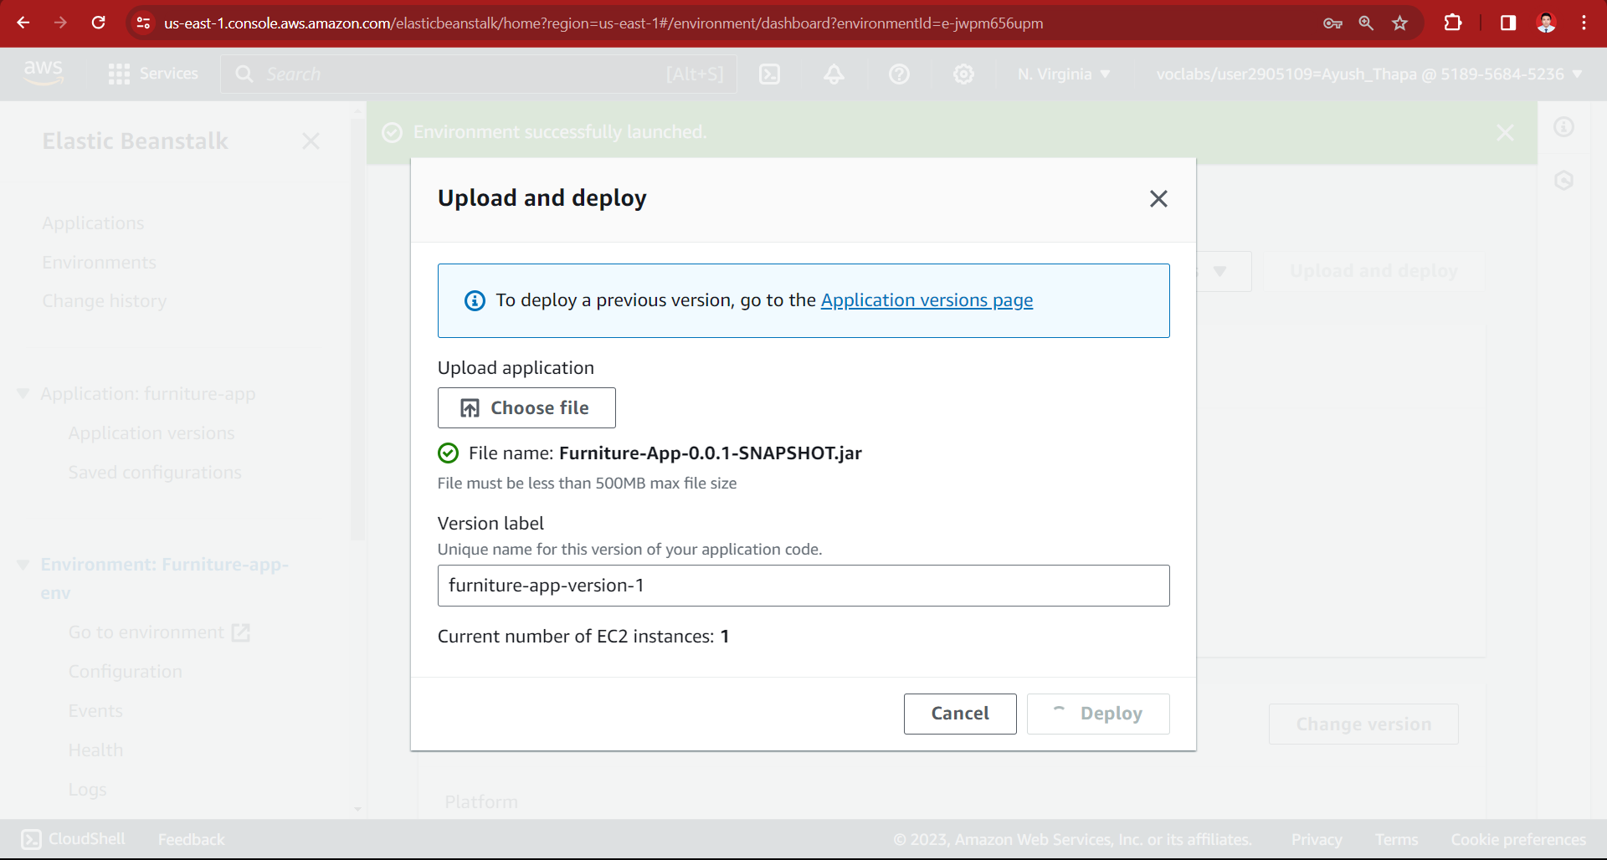

1. Application deployed

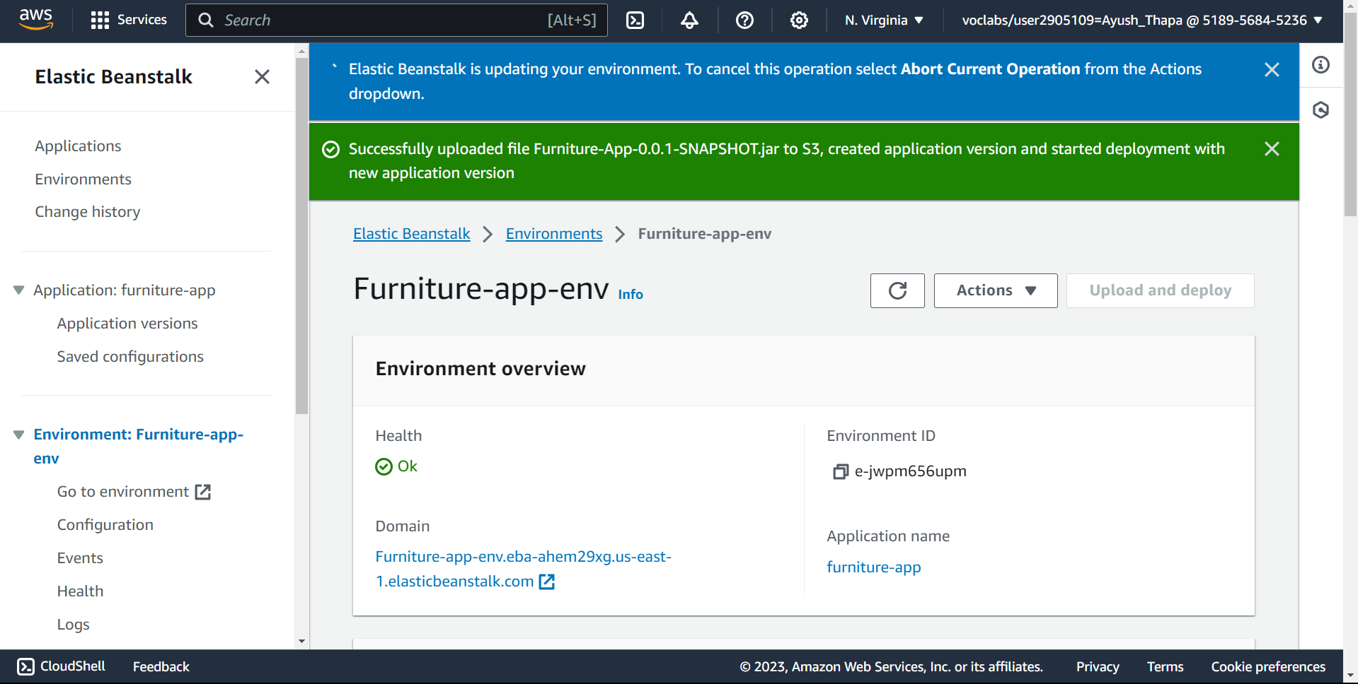

Here, we create two service in AWS i.e. RDS and Elastic Beanstalk

Testing:

Testing using Postman

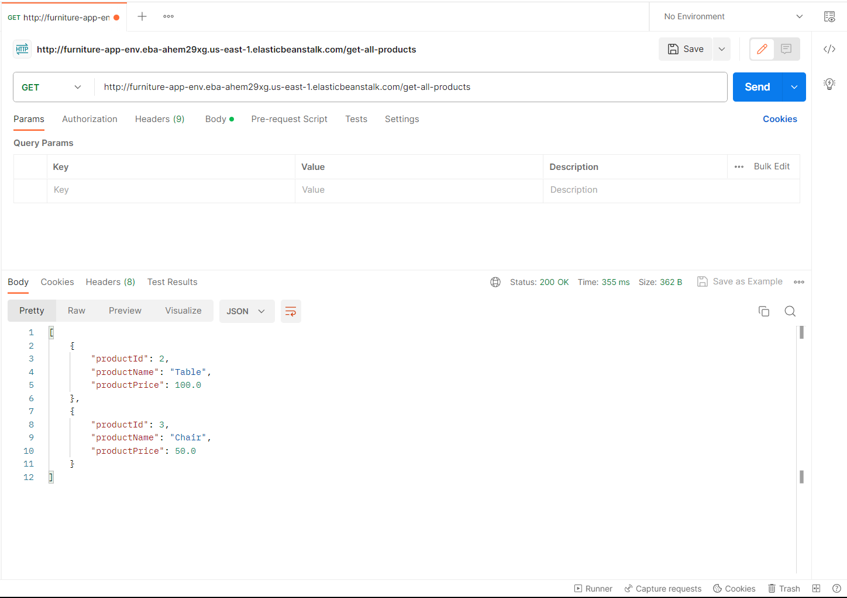

Get the all products

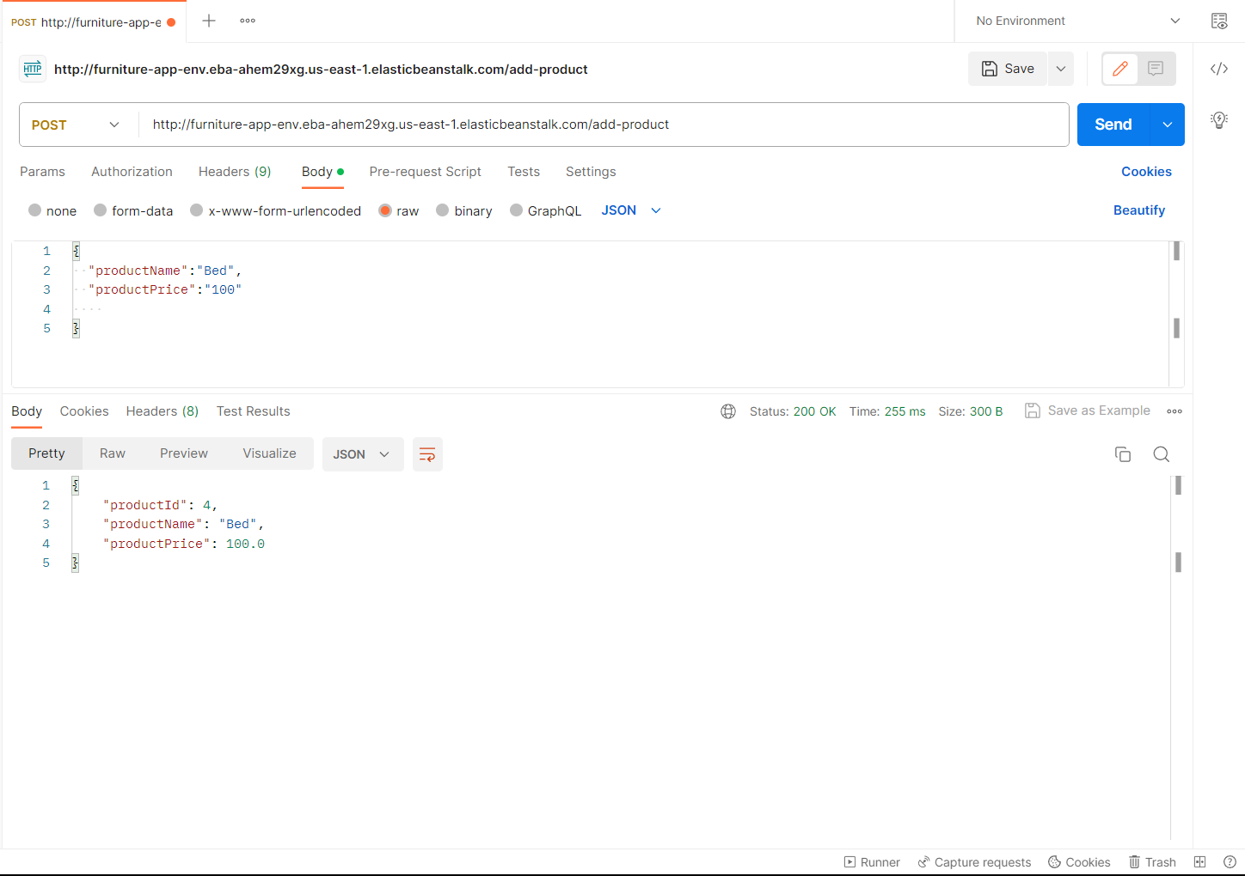

Add product

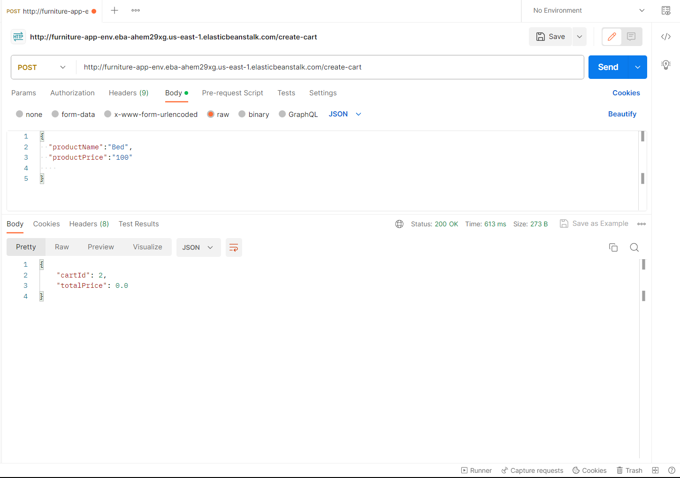

Create cart

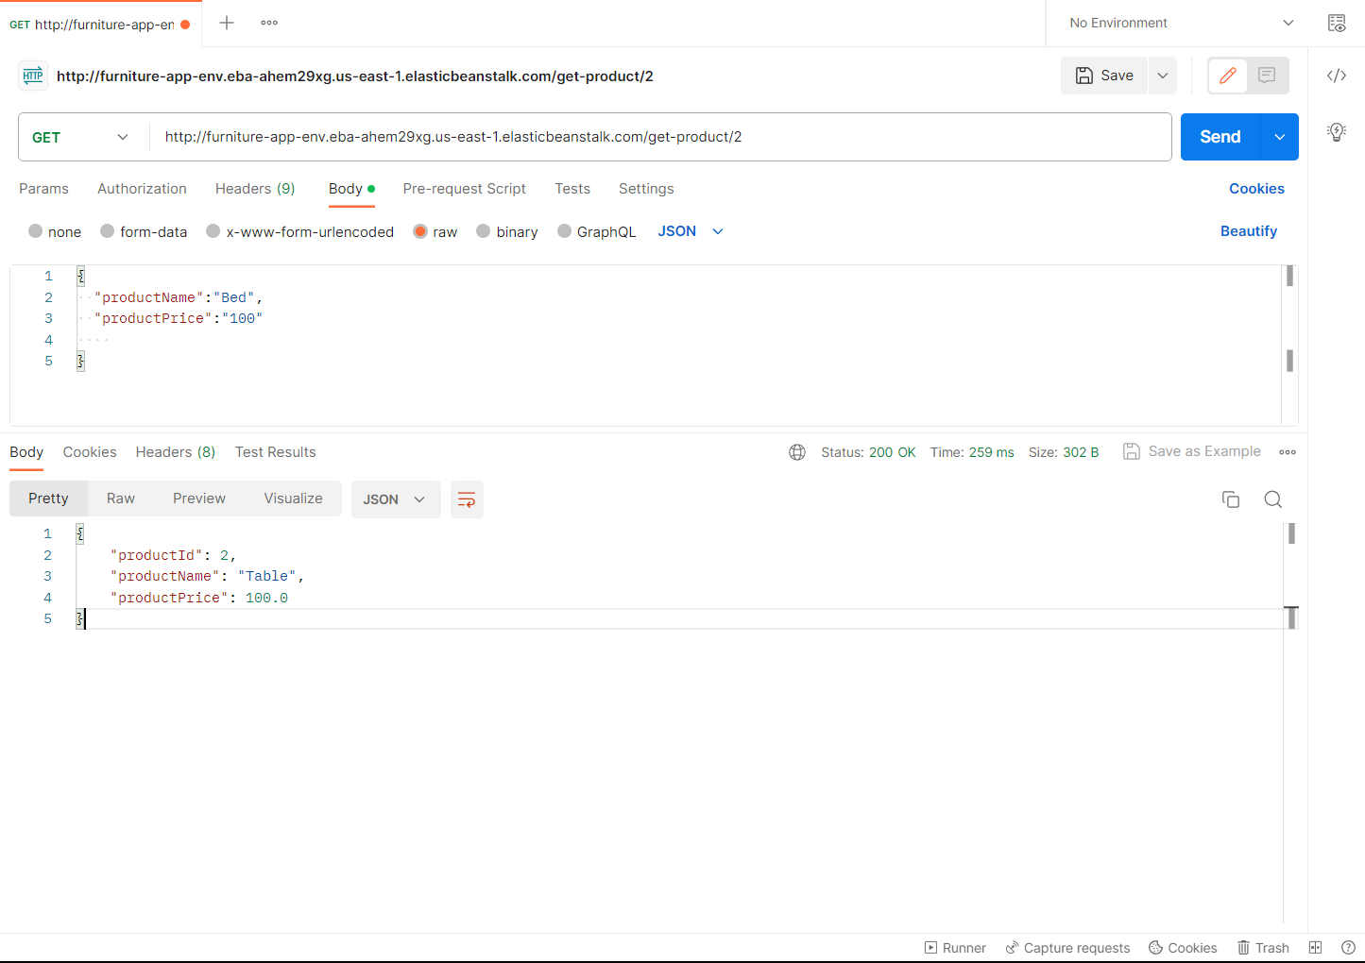

Get product by its id

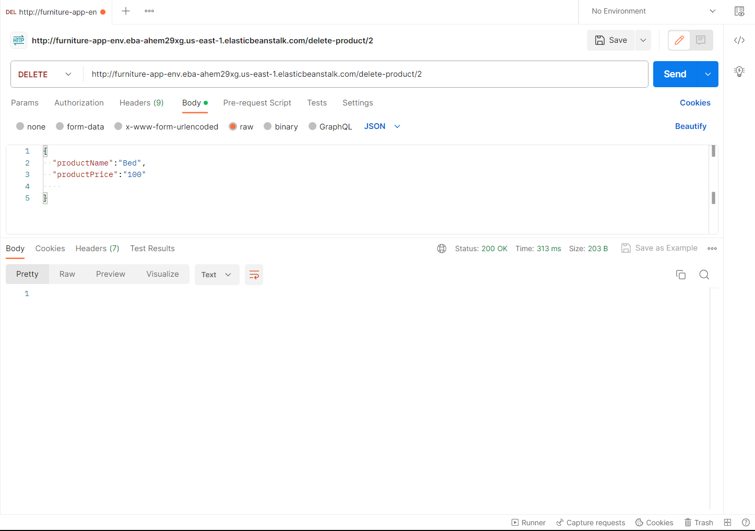

Delete product

# Conclusion and Reflection

In conclusion, our exploration of cloud versus on-premise solutions has shed light on the dynamic landscape of modern computing. The advantages of cloud services, including flexibility, scalability, and cost-effectiveness, present compelling reasons for businesses to consider migrating from traditional on-premise infrastructure. While cloud solutions offer unprecedented opportunities for innovation and growth, it's essential to recognize that on-premise solutions still hold value, particularly for organizations with stringent security and compliance requirements.

Our examination of various cloud service models and types has underscored the importance of choosing the right approach based on specific business needs. Whether opting for IaaS, PaaS, or SaaS, organizations must carefully assess their requirements to make informed decisions that align with their goals and objectives.

Furthermore, our exploration of leading cloud vendors, such as AWS, Azure, and Google Cloud, emphasizes the significance of selecting a provider that aligns with the unique demands of a project. Each vendor offers a diverse set of services and features, and understanding their strengths and weaknesses is crucial for successful cloud adoption.

The practical demonstration of developing and deploying a web application on AWS Elastic Beanstalk has showcased the efficiency and simplicity of cloud-based development platforms. While challenges may arise during the deployment process, the overall experience underscores the potential for streamlined, scalable, and cost-effective application hosting.

Completing this project, learned how to create AWS service, especially RDS and Elastic Beanstalk, how to connect a RDS to server-side application and how to connect server-side application with client application. Technology like postman was learned. This has established a basic understanding of how a application is deployed in cloud and what its advantages are.

# References

AWS, 2023. *Welcome.* [Online]   
Available at: https://docs.aws.amazon.com/elasticbeanstalk/latest/dg/Welcome.html  
[Accessed 17 December 2023].

Camp, A., 2016. *elastic-beanstalk-advantages-and-drawbacks.* [Online]   
Available at: https://medium.com/@acamp/elastic-beanstalk-advantages-and-drawbacks-be814615af01  
[Accessed 17 December 2023].

Coursera, 2023. *aws-vs-azure-vs-google-cloud.* [Online]   
Available at: https://www.coursera.org/articles/aws-vs-azure-vs-google-cloud  
[Accessed 18 December 2023].

Duff, J., 2023. *fortune-500-companies-that-use-aws.* [Online]   
Available at: https://www.thomsondata.com/blog/fortune-500-companies-that-use-aws/  
[Accessed 16 December 2023].

Haranas, M., 2023. *microsoft-aws-google-cloud-market-share.* [Online]   
Available at: https://www.crn.com/news/cloud/microsoft-aws-google-cloud-market-share-q3-2023-results?page=1  
[Accessed 16 December 2023].

IntelliPaat, 2023. *aws-vs-azure-vs-google-cloud.* [Online]   
Available at: https://intellipaat.com/blog/aws-vs-azure-vs-google-cloud/#no3  
[Accessed 18 December 2023].

Kanade, V., 2022. *what-is-platform-as-a-service.* [Online]   
Available at: https://www.spiceworks.com/tech/cloud/articles/what-is-platform-as-a-service/  
[Accessed 14 December 2023].

Microsoft Azure, 2023. *What is SaaS?.* [Online]   
Available at: https://azure.microsoft.com/en-us/resources/cloud-computing-dictionary/what-is-saas#:~:text=Software%20as%20a%20service%20(SaaS,from%20a%20cloud%20service%20provider.  
[Accessed 15 December 2023].

Rahul, 2023. *AWS market share.* [Online]   
Available at: https://www.wpoven.com/blog/aws-market-share/#:~:text=As%20per%20the%20recent%20reports,as%20Google%20and%20Microsoft's%20Azure.  
[Accessed 16 December 2023].

Smact Works, 2019. *5-major-benefits-of-platform-as-a-service-paas.* [Online]   
Available at: https://www.smactworks.com/insights/blogs/2019/10/5-major-benefits-of-platform-as-a-service-paas.html  
[Accessed 14 December 2023].

Team Cleo, 2023. *knowledge base on premise vs cloud.* [Online]   
Available at: https://www.cleo.com/blog/knowledge-base-on-premise-vs-cloud#:~:text=Simply%20put%2C%20the%20difference%20between,web%20browser%20or%20other%20interface.  
[Accessed 15 December 2023].

The IoT Academy, 2023. *What is IaaS in Cloud Computing: Types and Applications.* [Online]   
Available at: https://www.theiotacademy.co/blog/iaas-in-cloud-computing/  
[Accessed 15 December 2023].

Thomson Data, 2023. *companies-that-use-google-cloud.* [Online]   
Available at: https://www.thomsondata.com/customer-base/companies-that-use-google-cloud.php  
[Accessed 16 December 2023].

Tracey, D., 2020. *Who's Using Microsoft Azure?.* [Online]   
Available at: https://www.contino.io/insights/whos-using-microsoft-azure-2020  
[Accessed 16 December 2023].

Trad, O., 2023. *types of paas.* [Online]   
Available at: https://devtalents.com/types-of-paas/  
[Accessed 15 December 2023].

Zhang, M., 2023. *top cloud service providers.* [Online]   
Available at: https://dgtlinfra.com/top-cloud-service-providers/  
[Accessed 15 December 2023].

Bhatia, V., 2023. *synopsys.* [Online]   
Available at: https://www.synopsys.com/cloud/insights/essential-cloud-computing-characteristics.html#:~:text=The%20National%20Institute%20of%20Standards,rapid%20elasticity%2C%20and%20measured%20service.  
[Accessed 11 December 2023].

Cloudflare, 2023. *Cloudflare.* [Online]   
Available at: https://www.cloudflare.com/learning/cloud/what-is-the-cloud/  
[Accessed 10 December 2023].

Mell, p., & Grance, T.(2011) National Institute of Standards and Technology. [Online]

Available at: https://nvlpubs.nist.gov/nistpubs/legacy/sp/nistspecialpublication800-145.pdf

[Accessed 11 December 2023].

GoogleCloud, 2023. *IaaS.* [Online]   
Available at: https://cloud.google.com/learn/what-is-iaas#:~:text=IaaS%2C%20or%20Infrastructure%20as%20a,way%20requires%20time%20and%20capital.  
[Accessed 14 December 2023].

Kanade, V., 2022. *what-is-platform-as-a-service.* [Online]   
Available at: https://www.spiceworks.com/tech/cloud/articles/what-is-platform-as-a-service/  
[Accessed 14 December 2023].

Kumar, A., 2023. *Top 3 Cloud Computing Service Models: SaaS | PaaS | IaaS.* [Online]   
Available at: https://k21academy.com/amazon-web-services/aws-solutions-architect/cloud-service-models/  
[Accessed 11 December 2023].